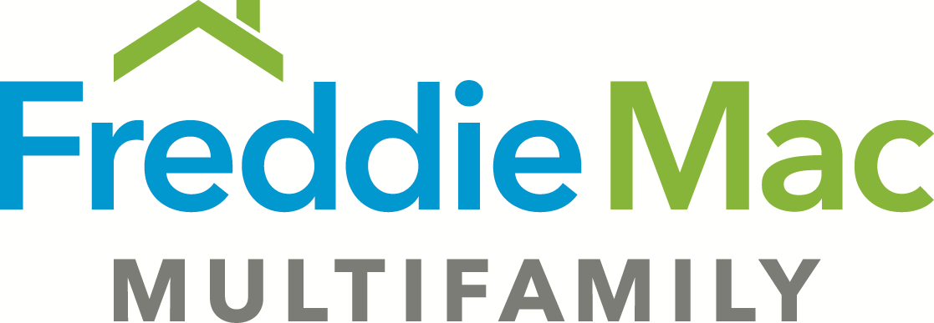

Loan Agreement Rider – TAH Express
Tax Abatement (Revised 05-31-2018)

- Section 3.03(s) is deleted and replaced with the following:

(s) Borrower fails to comply with the requirements of Section 10.22 of the Loan Agreement, and as a result the Tax Abatement is terminated.

- Section 10.22 is deleted and replaced with the following:

10.22 Tax Abatement.

(a) Additional Representations and Warranties. Borrower represents and warrants to Lender as follows as of the Effective Date:

(i) The Mortgaged Property has been granted the full or partial exemption or abatement of certain Taxes (“Tax Abatement”) pursuant to a tax program established under the laws governing tax abatements in the Property Jurisdiction (“Tax Abatement Program”).

(ii) The Tax Abatement is administered by a Governmental Authority with responsibility for collecting the Taxes that are subject to the Tax Abatement (“Tax Abatement Agency”).

(iii) Borrower has provided to Lender all documentation material to the Tax Abatement and confirms that all such documentation is complete and accurate in all respects and includes all amendments, schedules and exhibits (“Tax Abatement Documents”).

(iv) Borrower has at all times adhered to any income, rent or other restrictions or requirements, if any, imposed by the Tax Abatement Program.

(v) Borrower has not received any notice from the Tax Abatement Agency indicating that Borrower is in default under the Tax Abatement Program or that the Tax Abatement has been or will be terminated.

(b) Additional Covenants.

(i) Borrower will comply with all of the Tax Abatement Program and Tax Abatement Document requirements in order to maintain the Tax Abatement, including each of the following:

(A) Filing all documentation necessary to maintain and continue or renew the Tax Abatement.

(B) Adhering to any income, rent or other restrictions or requirements, if any, imposed by the Tax Abatement Program or Tax Abatement Documents.

(ii) Borrower will exercise all rights and opportunities to renew or extend the Tax Abatement.

(iii) Borrower will not amend or terminate the Tax Abatement Documents without the prior written consent of Lender.

(iv) Borrower will promptly provide to Lender a copy of any notice Borrower receives alleging that Borrower is in breach of the requirements of the Tax Abatement Program or the Tax Abatement Documents or that either Borrower’s Tax Abatement or the Tax Abatement Program has been or will be terminated.

(v) In connection with any Transfer request made by Borrower, Borrower will notify Lender if the Transfer requires the consent of the Tax Abatement Agency or may result in the termination of the Tax Abatement.

(c) Additional Events of Default. The following are additional Events of Default under this Loan Agreement:

(i) Any default, event of default, or breach (however such terms may be defined in the Tax Abatement Program or Tax Abatement Documents) under either the Tax Abatement Program or the Tax Abatement Documents which continues beyond the applicable cure period, if any.

(ii) Any Transfer that would cause the Tax Abatement to terminate.

