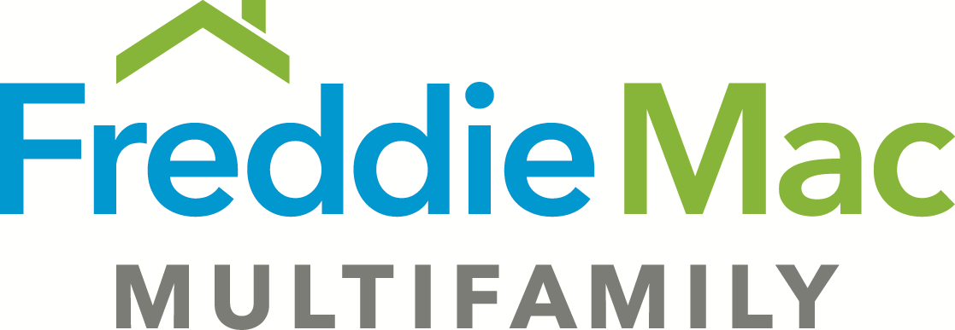

Loan Agreement Rider – TAH Express
Subordinate Financing (Revised 4-1-2018)

The Mortgaged Property is subject to a subordinate loan (“Subordinate Loan”) made by subordinate lender (“Subordinate Lender”) to Borrower, as evidenced by a note (“Subordinate Note”) and secured by a mortgage (“Subordinate Mortgage”).

- The following new table is added to Article I of the Loan Agreement:

Subordinate Financing
Subordinate Lender
Subordinate Loan Amount
Subordinate Loan Document Date

- Section 8.01(t) is deleted and replaced with the following:

(t) Any default, event of default or breach (however such terms may be defined in the Subordinate Note, the Subordinate Mortgage and all other documents evidencing, securing or governing the Subordinate Loan (the “Subordinate Loan Documents”) after the expiration of any applicable notice and/or cure periods under the Subordinate Loan Documents.
.

