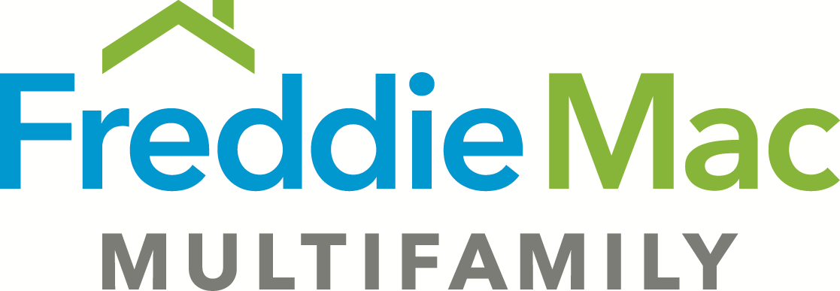
Seller’s Certification of Outstanding Items – TAH Express
(Revised 4/1/2018)
Borrower:
Lender:
Date of Certification:

In the Commitment/Application for the loan identified above, certain items required Freddie Mac’s review and approval, either prior to origination of the Loan or prior to Freddie Mac’s purchase of the Loan (“Outstanding Items”).

Lender certifies to Freddie Mac (either in its own capacity or through its Single Counsel for this Loan) that each of the Outstanding Items is listed below and that except as noted below, Lender has received Freddie Mac’s approval for each of these Outstanding Items.

Outstanding Items | Delivery Requirement  (mark as appropriate) |  | Exceptions/Comments
List each Outstanding Item from the Application/Commitment; include the appropriate section reference | Prior to Origination | Prior to Purchase | (if blank, there are no exceptions and the Outstanding Item is complete and approved by Freddie Mac)

[SIGNATURE]

