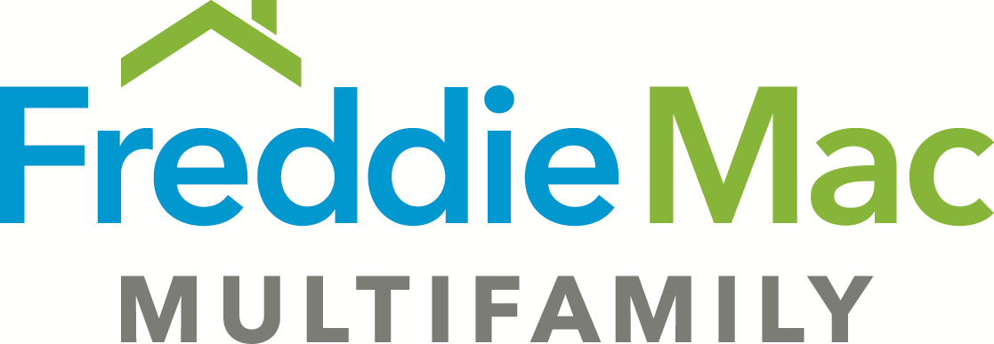
Omnibus Assignment - SBL (Revised 6-15-2020)
Borrower:
Lender:
Effective Date:
Loan Amount:

Lender assigns and transfers to the Federal Home Loan Mortgage Corporation, a corporation organized and existing under the laws of the United States, all of its right, title, and interest in each document set forth below in the “List of Documents Being Assigned” relating to the loan described above.

List of Documents Being Assigned

1. Loan Agreement
2. Guaranty [LIST EACH GUARANTY SEPARATELY AND INDICATE THE NAME OF THE GUARANTOR FOR EACH]

[LIST ANY ADDITIONAL DEAL-SPECIFIC, NON-RECORDED DOCUMENTS EXECUTED BY BORROWER IN FAVOR OF LENDER, EXCEPT THAT NONE OF THE FOLLOWING SHOULD BE LISTED IN THIS ASSIGNMENT:

NOTE
SECURITY INSTRUMENT
O&M PLANS OR AGREEMENTS
MOISTURE MANAGEMENT PLAN
TENANT ESTOPPELS
REPAIR LETTER - OPERATIONAL REPAIRS.]

[INSERT SELLER SIGNATURE]

