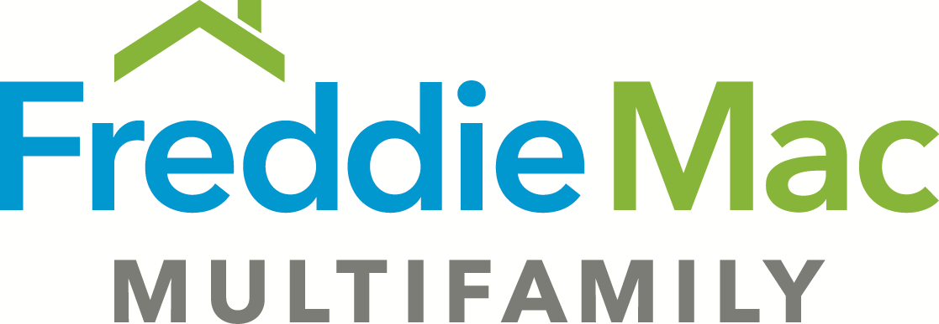
Loan Agreement Rider – TAH Express
Guarantor Requirements
(05-20-2019)

The following changes are made to the Loan Agreement which precedes this Rider:

A. Section 8.01(x) is deleted and replaced with the following:

(x) Guarantor fails to comply with the provisions of the Section of the Guaranty entitled “Material Adverse Change” or “Minimum Net Worth/Liquidity Requirements,” as applicable.

