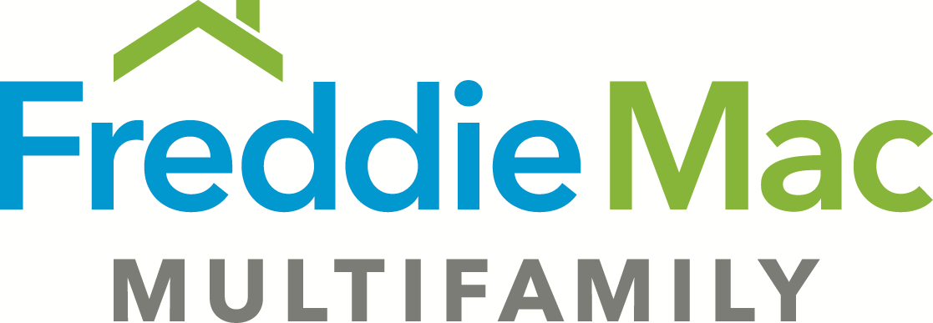
Financing Statement Exhibit B – TAH Express
(Revised 4-1-2018)

EXHIBIT B

All of Debtor’s present and future right, title, and interest in and to all of the following:

(1) “Fixtures,” which means all property owned by Debtor which is attached to the real property described in Exhibit A (“Land”) and/or the improvements located on the Land (“Improvements”) (“Property” means the Land and/or the Improvements) so as to constitute a fixture under applicable law, including: machinery, equipment, engines, boilers, incinerators and installed building materials; systems and equipment for the purpose of supplying or distributing heating, cooling, electricity, gas, water, air or light; antennas, cable, wiring and conduits used in connection with radio, television, security, fire prevention or fire detection or otherwise used to carry electronic signals; telephone systems and equipment; elevators and related machinery and equipment; fire detection, prevention and extinguishing systems and apparatus; security and access control systems and apparatus; plumbing systems; water heaters, ranges, stoves, microwave ovens, refrigerators, dishwashers, garbage disposers, washers, dryers and other appliances; light fixtures, awnings, storm windows and storm doors; pictures, screens, blinds, shades, curtains and curtain rods; mirrors; cabinets, paneling, rugs and floor and wall coverings; fences, trees and plants; swimming pools; and exercise equipment.

(2) “Personalty,” which means all of the following:

(i) Accounts (including deposit accounts) of Debtor related to the Property.

(ii) Equipment and inventory owned by Debtor, which are used now or in the future in connection with the ownership, management or operation of the Land or Improvements or are located on the Land or Improvements, including furniture, furnishings, machinery, building materials, goods, supplies, tools, books, records (whether in written or electronic form) and computer equipment (hardware and software).

(iii) Other tangible personal property owned by Debtor which is used now or in the future in connection with the ownership, management or operation of the Land or Improvements or is located on the Land or in the Improvements, including ranges, stoves, microwave ovens, refrigerators, dishwashers, garbage disposers, washers, dryers and other appliances (other than Fixtures).

(iv) Any operating agreements relating to the Land or the Improvements.

(v) Any surveys, plans and specifications and contracts for architectural, engineering and construction services relating to the Land or the Improvements.

(vi) All other intangible property, general intangibles and rights relating to the operation of, or used in connection with, the Land or the Improvements, including all governmental permits relating to any activities on the Land and including subsidy or similar payments received from any sources, including a “Governmental Authority” (defined as any board, commission, department, agency or body of any municipal, county, state or federal governmental unit, or any subdivision of any of them, that has or acquires jurisdiction over the Property, or the use, operation or improvement of the Property, or over Debtor).

(vii) Any rights of Debtor in or under any letter of credit required under the terms of the Loan Agreement evidencing and securing the loan (“Loan”) secured by this financing statement (“Loan Agreement”).
.
(3) All current and future rights, including air rights, development rights, zoning rights and other similar rights or interests, easements, tenements, rights of way, strips and gores of land, streets, alleys, roads, sewer rights, waters, watercourses and appurtenances related to or benefiting the Land or the Improvements, or both, and all rights-of-way, streets, alleys and roads which may have been or may in the future be vacated.

(4) All proceeds paid or to be paid by any insurer of the Land, the Improvements, the Fixtures, the Personalty or any other part of the Property, whether or not Debtor obtained the insurance pursuant to Secured Party’s requirement.

(5) All awards, payments and other compensation made or to be made by any Governmental Authority with respect to the Land, or if Debtor’s interest in the Land is pursuant to a ground lease, the ground lease and the leasehold estate created by such ground lease (“Leasehold Estate”), the Improvements, the Fixtures, the Personalty or any other part of the Property, including any awards or settlements resulting from condemnation proceedings or the total or partial taking of the Land, the Improvements, the Fixtures, the Personalty or any other part of the Property under the power of eminent domain or otherwise and including any conveyance in lieu thereof.

(6) All contracts, options and other agreements for the sale of the Land, or the Leasehold Estate, as applicable, the Improvements, the Fixtures, the Personalty or any other part of the Property entered into by Debtor now or in the future, including cash or securities deposited to secure performance by parties of their obligations.

(7) All “Rents,” which means all rents (whether from residential or non-residential space), revenues and other income of the Land or the Improvements, parking fees, laundry and vending machine income and fees and charges for food, health care and other services provided at the Property, whether now due, past due or to become due, and deposits forfeited by tenants, and, if Debtor is a cooperative housing corporation or association, maintenance fees, charges or assessments payable by shareholders or residents under proprietary leases or occupancy agreements, whether now due, past due or to become due.

(8) All “Leases,” which means all present and future leases, subleases, licenses, concessions or grants or other possessory interests in force now or hereafter, whether oral or written, covering or affecting the Property, or any portion of the Property (including proprietary leases or occupancy agreements if Debtor is a cooperative housing corporation), and all modifications, extensions or renewals.

(9) All earnings, royalties, accounts receivable, issues and profits from the Land, the Improvements or any other part of the Property, and all undisbursed proceeds of the Loan.

(10) All deposits to a “Reserve Fund” (defined as all amounts deposited by the Debtor with Secured Party in connection with the Loan for the payment of taxes or insurance premiums or as otherwise required pursuant to the Loan Agreement), whether in cash or as a letter of credit.

(11) All refunds or rebates of taxes by a Governmental Authority (other than refunds applicable to periods before the real property tax year in which this financing statement is recorded or filed) or insurance premiums by an insurance company.

(12) All tenant security deposits which have not been forfeited by any tenant under any Lease and any bond or other security in lieu of such deposits.

(13) All names under or by which the Property or any part of it may be operated or known, and all trademarks, trade names, and goodwill relating to any of the Property.

(14) All proceeds from the conversion, voluntary or involuntary, of any of the above into cash or liquidated claims, and the right to collect such proceeds.

(15) If the Property is subject to a “HAP Contract” as defined in the Loan Agreement, all housing assistance payments payable with respect to the Property by the United States Department of Housing and Urban Development, a Governmental Authority (acting through any authorized representative), a quasi-governmental authority, or a private non-profit entity that is either entitled to enforce the provision of the HAP Contract or is obligated under the HAP Contract to provide housing assistance payments to Borrower.

