Servicer Remittances
myOptigo® User Guide
October 2023
DATA CLASSIFICATION

Quick Use Tips

To view content: Click the arrow by the large header to expand that section. Click the arrow again to close the section.

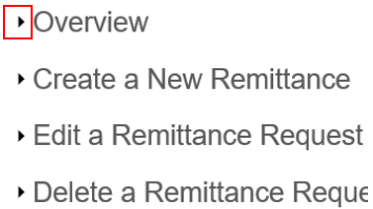

To expand/collapse all sections: Right click on a header, go to Expand/Collapse, select the appropriate option.

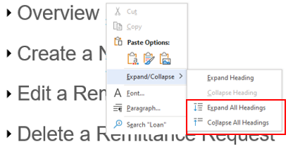

To read the screenshots: Match the numbered list item description to the number in each screenshot.

This document is protected from modification or manipulation.

Overview
With myOptigo® Servicer Remittances, servicers can initiate remittance transactions for their monthly principal and interest (P&I) and pay-off and related fees. The portal automatically generates an ACH transaction request to draft funds from the servicer P&I custodial account to be sent to Freddie Mac.

In myOptigo, servicers will be able to:
- Create new remittance requests, edit remittance requests, delete remittance requests and export data from the servicer remittance history.
- View remittance request details and their current statuses in the transaction process on the Remittance History page.
- Submit multiple new remittances at once and attach documentation as needed.
- Initiate a request to be drafted as early as one business day in the future or up to 30 days in advance of the current system date.

Remittance History Page Definitions
- Date Entered: The date the remittance record was created by the servicer.
  - Information Icon: This icon is displayed to the left of the Date Entered column and notifies servicers that the Date Entered will not match the “Call-In” date found on the Servicer Cash Statement. The Call-In date will be one business day before the date the funds are drafted from the servicer account.
- Type: Remittance types (Payoff, Non Payoff, Fee).
- Amount Submitted: The remittance amount submitted by the servicer.
- Draft Date: The date when the remittance will be drafted.
- Status: The current remittance status within the transaction process.
- Last Update: This column displays when the remittance request was last updated and by whom. The default value is the date and time entered and the name of the servicer who created the request.
- Actions: This provides the capability to view attachments submitted by the remitter, edit a remittance and delete a remittance.
  - Information icon: This icon is displayed to the left of the Actions column and notifies servicers of acceptable file types to upload (txt, xlsx, xls, pdf, doc, docx, csv) and maximum file size (256K).

Status Definitions
- Requested: The remittance request is not ready for ACH processing.
- Submitted: The request is prepared for ACH processing and is ready to be sent to the Freddie Mac ACH processor
- Processing: The Freddie Mac ACH processor has initiated the ACH request.
- Completed: Freddie Mac has received the funds.
- Failed: Freddie Mac was unable to extract funds from servicer accounts after the ACH process has occurred (i.e., due to a business issue such as insufficient funds).

Create a New Remittance
To create a new remittance request in myOptigo, follow the steps below:

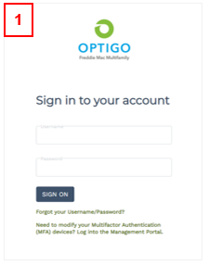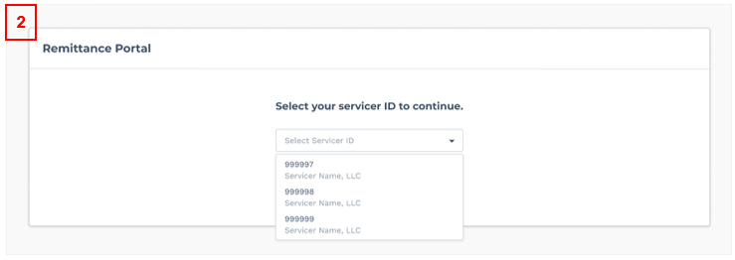
- Log into myOptigo Servicer Remittances.
- Once logged in, the drop-down will display existing Servicer IDs associated with the servicer who has logged in. Select a Servicer ID and click Continue.
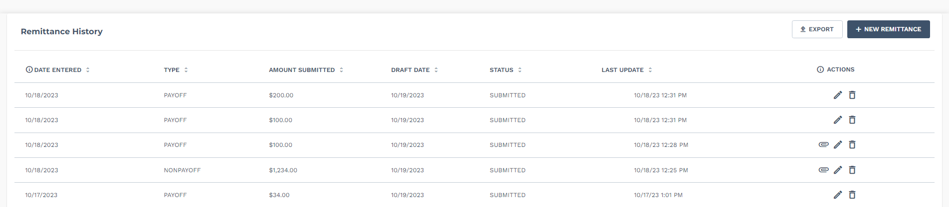
3

- Click the ‘New Remittance’ button on the Remittance History page.

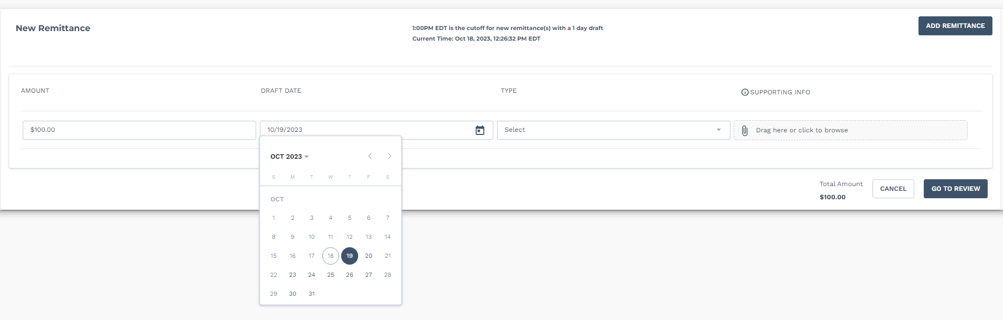
4

- On the New Remittance page, please do the following:
  - Enter the remittance value in the Amount field. An error message will appear if the value exceeds the maximum limit.
  - Click the Calendar icon to select a draft date. Prior to 1:00 p.m. ET, the default date will be set to one business day in the future from the current day. After 1:00 p.m. ET, the default draft date will be set to two business days in the future from the current day. Only valid business dates, based on the Federal Reserve calendar, can be selected.
  - Select a remittance type from the drop-down: Payoff, Non Payoff or Fee.

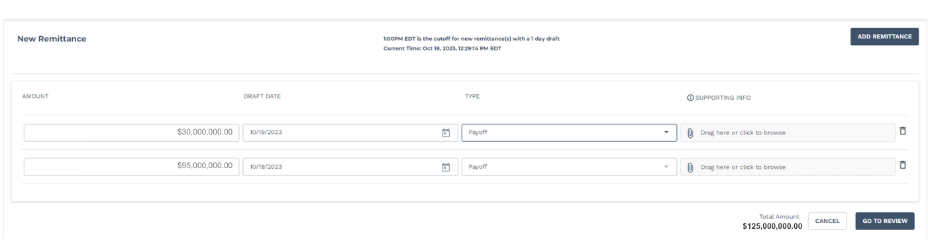
5
- Remittances that are $100 million or greater must be broken into separate remittances. The Total Amount at the bottom of the screen will automatically update based on each row that is added or deleted from the Amount fields.

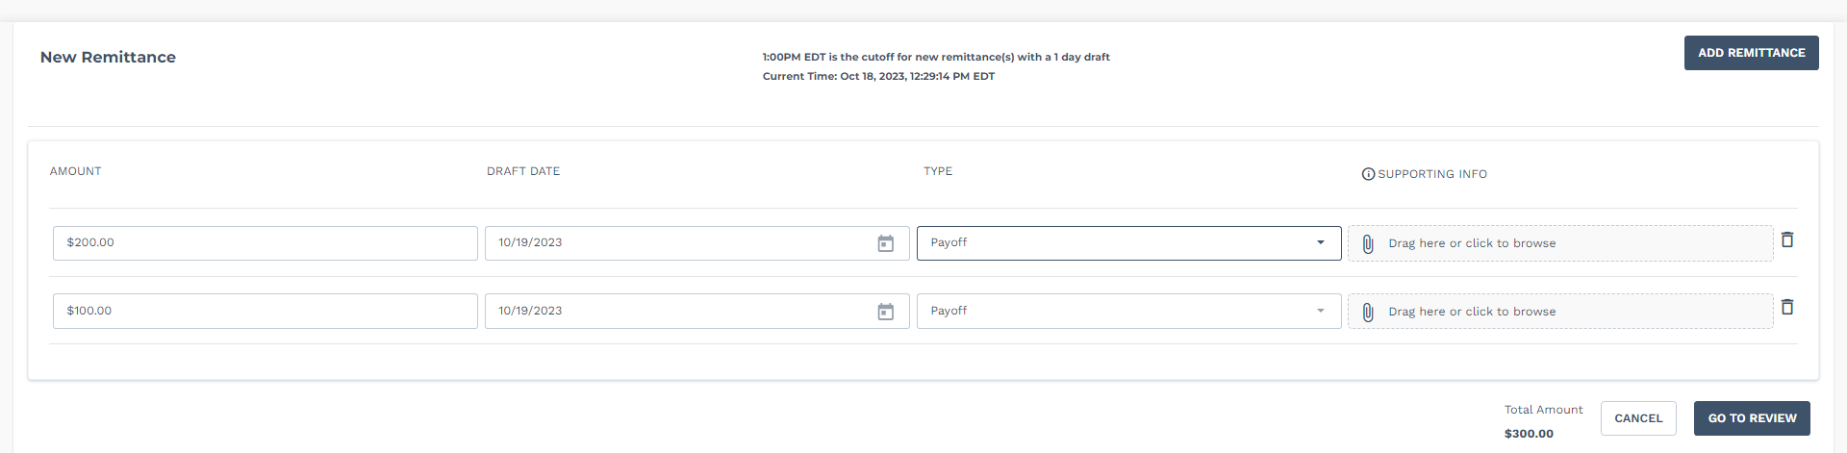
6
- To attach documentation to the remittance, select a file by clicking the Paper Clip icon under the Supporting Info column or drag the file into that field.
  - Valid file types include: txt, xlsx, xls, pdf, doc, docx and csv.
  - File sizes up to 256K are accepted.
  - The file name should include only letters, numbers, periods, dashes or a blank space. This is not a mandatory field.

7

- To submit multiple remittances, click the ‘Add Remittance’ button and input the remittance information into the row for that amount. Click the Trash Can icon to delete a remittance row.
- Once all fields are inputted and there are no issues, click the ‘Go to Review’ button at the bottom of the page.

9
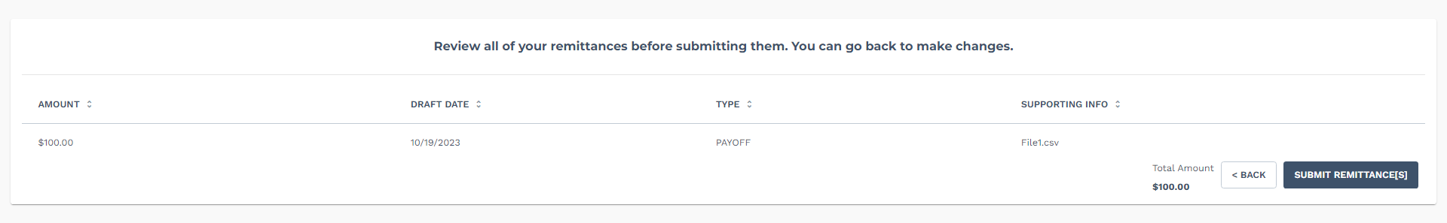

- On the Review page, the new remittance request information is displayed in a read-only format. To make an edit, click the ‘Back’ button. To submit the listed remittances, click the ‘Submit Remittance(s)’ button.

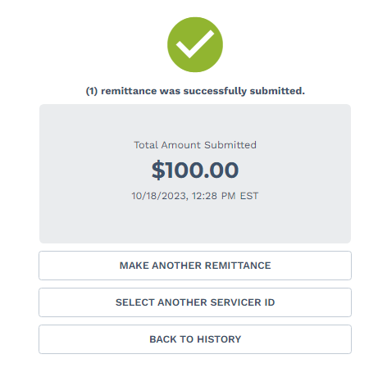
10

- Upon successful submission, a confirmation page will display the date and time stamp of the new remittance request.

Edit a Remittance Request
To edit a remittance request, follow the steps below.

Note: Servicers can only edit remittances with a “Submitted” status.

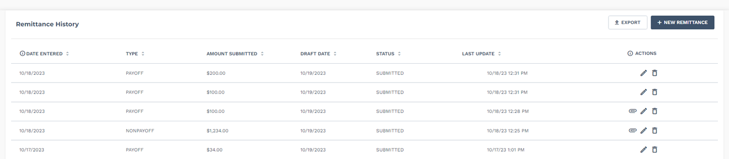
1

- On the Remittance History page, click the Pencil icon within the remittance row to open the Edit panel.

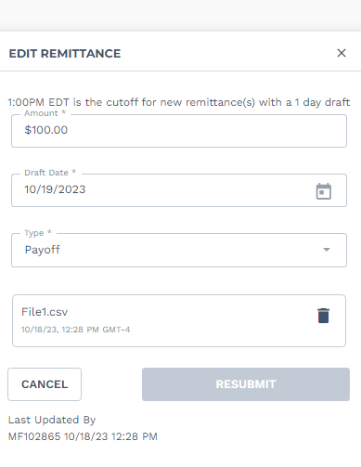
2
- Make changes to any of the fields in the Edit panel as needed, then click Resubmit. If no changes are made, the ‘Resubmit’ button will not be available.
- Amount field: Accepts numerical values
- Date Drafted: Click the Calendar icon to select a new draft date
- Type drop-down: Includes Payoff, Non Payoff and Fee
- Attach File: Optional

Note: Users must update the draft date if a two-day draft remittance request is edited within two days of the draft date.

Delete a Remittance Request
To delete a remittance request, follow the below steps.

Note: Servicers can only delete remittances with a “Submitted” status.
1

- Click the Trash Can icon on the Remittance History page.

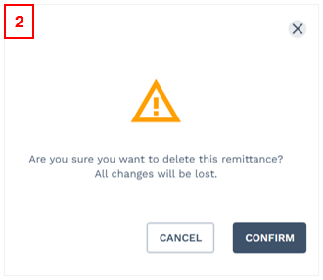

- A confirmation message will appear. To delete the remittance, click the ‘Confirm’ button. To exit from deleting, click the ‘Cancel’ button.
- Upon clicking the ‘Confirm’ button, a success message will appear confirming deletion. The remittance request will disappear from the Remittance History page.

Export Remittance History
To export a remittance request, follow the steps below.
1

- Click the ‘Export’ button on the Remittance History page.
2
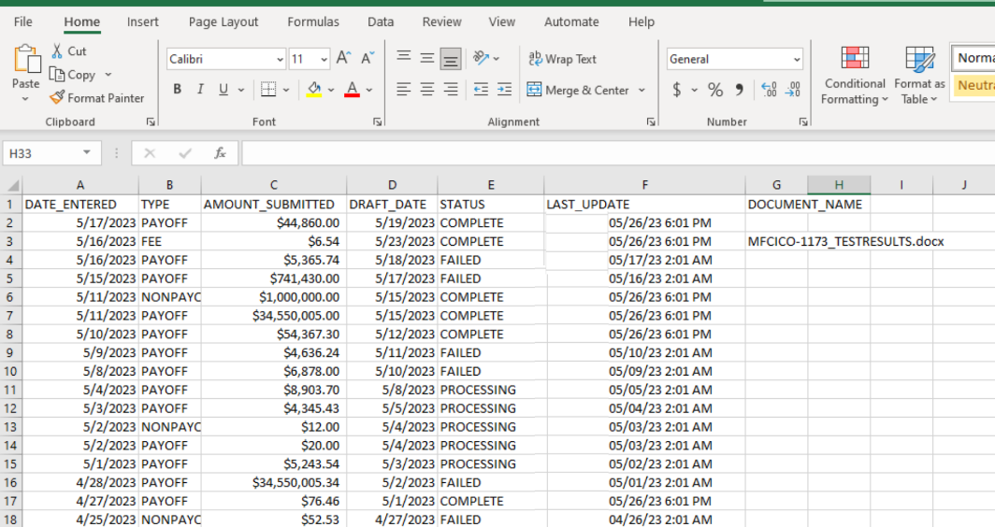
- All the records for that Servicer ID will be downloadable in an Excel spreadsheet.

Technical Help
If you encounter a technical issue while using the investor reporting features in myOptigo, contact the Multifamily Service Desk or your system administrator.

We recommend using the Google Chrome or Microsoft Edge internet browsers to access myOptigo for the best user experience.

