April 2024

Investor Reporting
myOptigo® User Guide
DATA CLASSIFICATION

Quick Use Tips

To view content: Click the arrow by the blue header to expand that section. Click the arrow again to close the section.

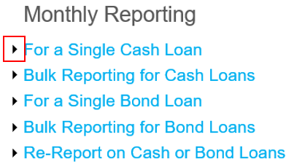

To expand/collapse all sections: Right click on a header, go to Expand/Collapse, select the appropriate option.

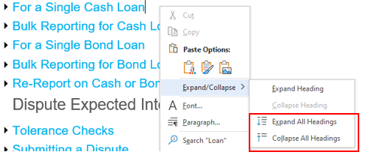

To read the screenshots: Match the numbered list item description to the number in each screenshot.

This document is protected from modification or manipulation.

Reporting Basics

Cash Loans Reporting Checklist
Please note the following checklist while reporting on Cash Loans in myOptigo®.

User Interface Reporting (Loan-Level/manual reporting)
- Principal and Interest
- Payoff Reporting (all types including securitization transfers)
  - Servicers must submit a payoff request to the Loan Accounting Payoff Team before attempting to report any payoff. For CME payoffs, you do not need to submit a payoff request to the Loan Accounting Team.
- Dispute Freddie Mac Expected Interest
- Delinquency Reporting (first three business days of the month)

Bulk Upload Reporting
The following fields must be reported via the Bulk Upload file option:
- Late fee
- Default interest
- Interest on arrears
- Capitalized items
- Noncash principal (non-payoff activity)
- Additional principal (non-payoff activity)
- Prepayment premium (non-payoff activity)

Reporting Reminders

Reporting Window
Starts: Second calendar day of month (recommendation to begin no earlier than 6:00 a.m. ET)
Ends: Second to last business day of the month (window closes at 8:00 p.m. ET)

Reporting Window example: July 2, 2020 through July 30, 2020

Monthly P&I Reporting
User can only report monthly principal & interest payments (P&I) for the current cycle (i.e., July transaction dates should be June 16, 2022 through July 15, 2022).

Payoffs
Payoffs that occur on any day of the current month can be reported during the Reporting Window for the month. Note that payoffs are dependent on monthly reporting being completed. The system will not allow you to report a payoff otherwise.

Refer to the best practices document for more details on payoffs.

Search/Navigation

Search for Cash or Bond Loans
The search bar can be found at the top of your myOptigo Portfolios homepage.

Search for a cash loan or view cash loan history by entering the Freddie Mac Loan Number, Servicer Loan Number or property address in the search bar. Follow these guidelines:
- Enter the Loan Number exactly, otherwise no results will be found.
- Do not use preceding zeros when searching by Servicer Loan Number.

Search for a bond loan or view bond loan history by entering the Freddie Mac Loan Number. You must enter the Loan Number exactly, otherwise no results will be found.

Search for:

Search Results:
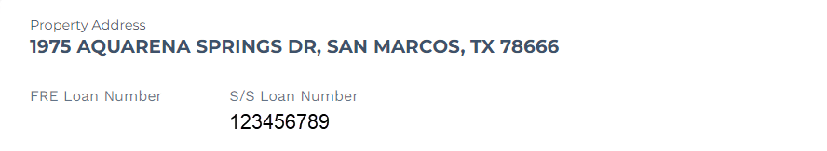

Portfolio View Search for Active Loans

Use the Portfolio View Search bar to find a cash or bond loan in the portfolio.
- Search for active cash loan by entering the FRE Loan No., Servicer Loan No., Servicer Principal, Expected Interest, Reporting Due Date, Date Collected, Beginning UPB, Ending UPB, Paid Through Date or LLR Status.
- Search for a bond loan by entering the FRE Loan No., Servicer Loan No., UPB, Paid Through Date, Last Reported Date, Total Expected Fees or Status.

Follow these guidelines:
- A minimum of three characters must be entered in the search bar.
- When searching for a dollar value, you must enter the commas and decimal points as applicable, i.e., entering “1,000” versus “1000” will not yield the same result.
- Do not enter the preceding zeros when searching by Servicer Loan Number.

Modify Servicer Loan Number
The Servicer Loan Number can be modified for cash and bond loans on the Portfolio View page or the Loan/Bond Details page.

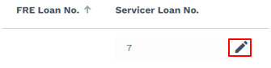

Hover over the Servicer Loan Number and click on the pencil icon to edit the field. Up to 20 permittable characters can be entered. Permitted characters are:
- All letters
- All numbers
- Special characters like periods (.), semi-colons (;), colons (:), asterisks (*) and dashes (-), including spaces

Note: Servicer Loan Numbers cannot be modified for loans or bonds that are paid off.

Monthly Reporting

For a Single Cash Loan
Complete monthly reporting on the Portfolio View page or the Loan Details page.
- Validate the Expected Interest.
- Enter the Servicer Principal.
- Enter the Date Collected. Note: Date Collected can range from the 16th of the prior month to the 15th of the current month and cannot be greater than today’s date.
  - Example 1: If today is March 12, the Date Collected can range from February 16 to March 12.
  - Example 2: If today is March 20, the Date Collected can range from February 16 to March 15.
- If applicable, complete these fields (only available on the Loan Details page): Additional Principal, Late Fee, Default Interest, Capitalized Items, Interest on Arrears, Negative Amortization, Noncash Writedown, Prepayment Premium.
- Click the Report button or select Report from the Report drop-down.
- When a loan is reported, the Paid Through date will roll forward one month, and the LLR Status will update to Reported.
- The Remittance Amount will be updated after reporting based on the values reported for the monthly payment.

Portfolio View Page:
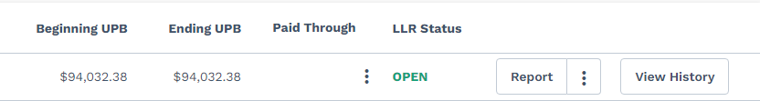

Loan Details Page:
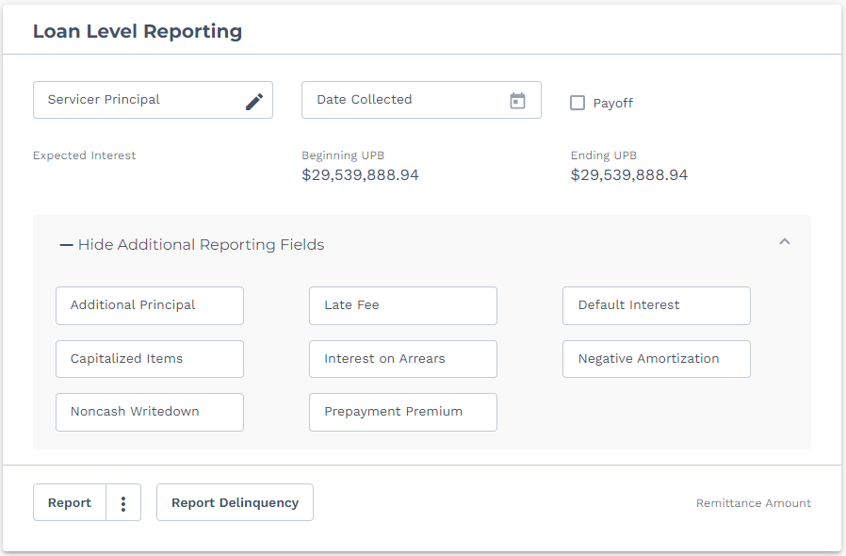
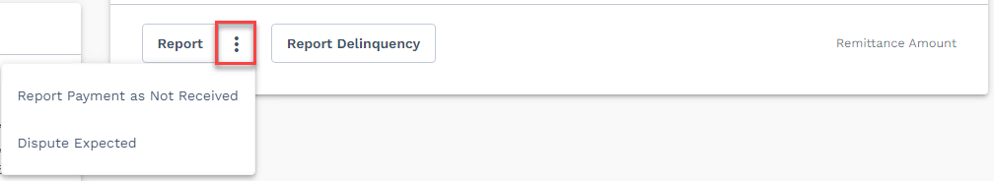
Other Options
- If the payment for the loan was not received, select Report Payment as Not Received from the Report drop-down.
  - Report Payment as Not Received will update the LLR Status to Reported, but the rest of the payment information in myOptigo will remain the same, including the Paid Through date.
- If the Expected Interest displayed is not correct according to your records, select Dispute Expected from the Report drop-down.
- Reporting on Newly Funded Loans is not expected, and Expected Interest may be $0.00.

Please see the Appendix: When to Expect Reporting on Newly Funded Loans for more details.

Bulk Reporting for Cash Loans

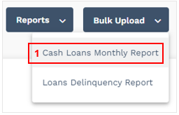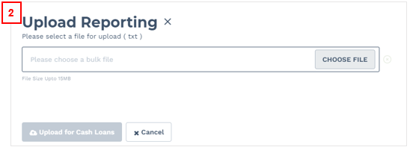
- Click the Bulk Upload button and select Cash Loans Monthly Report.
- Upload a .txt file with the applicable loan information. This file is the same file that was used in MSIR – no other file type is accepted.

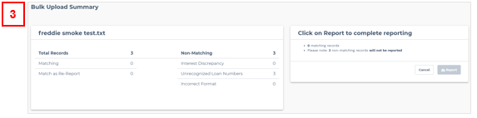
- After the file is uploaded, the Bulk Upload Summary page will display showing the number of Matching Records and Non-Matching Records. From here, you have two options:
  - Report only the matching records. The non-matching records will remain open.
  - Update the non-matching records prior to reporting and report all records at once.
- The Non-Matching Records with an Interest Discrepancy are displayed on the page. If the S/S Interest is correct and the FRE Expected Interest is not correct, select the three dots to Dispute Expected. Note: This will take you to the Dispute Path (see Dispute Expected Interest for Loans)
- The Non-Matching Records that have unrecognized loan numbers or are in incorrect format will not be shown. To find those records, closely look through the Open records and confirm the loan number is correct, and the data is in the correct format.
- Click the Report button to report on all matching records. The LLR Status of all loans will update to Reported.

For a Single Bond Loan
Complete monthly reporting on a single bond loan only on the Bond Details page. This is commonly referred to as reporting through the user interface (UI).

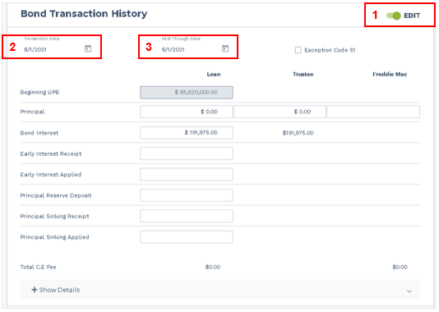

- Under Bond Transaction History, click the “Edit” toggle. All reportable fields will display as editable.
- Enter the Transaction Date. This is required if the dollar amount changes for either Principal and/or Interest. Note: Transaction Date can range from the 16th of the prior month to the 15th of the current month and cannot be greater than today’s date.
  - Example 1: If today is March 12, the Transaction Date can range from February 16 to March 12.
  - Example 2: If today is March 20, the Transaction Date can range from February 16 to March 15.
- Enter Paid Through Date (required field).

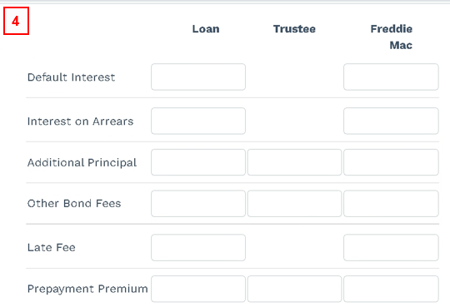
- If applicable, enter the Principal, Bond Interest, Early Interest Receipt, Early Interest Applied, Principal Reserve Deposit, Principal Sinking Receipt, Principal Sinking Applied, Default Interest, Interest on Arrears, Additional Principal, Other Bond Fees, Late Fees and Prepayment Premium. Note: Re-reporting via bulk will override anything that’s already been reported through the UI.

You can also report Alternate Balance Amounts for bond fees by expanding the Show Details section. Note: Fees can only be reported if there is an expected fee. Otherwise, leave the field blank.
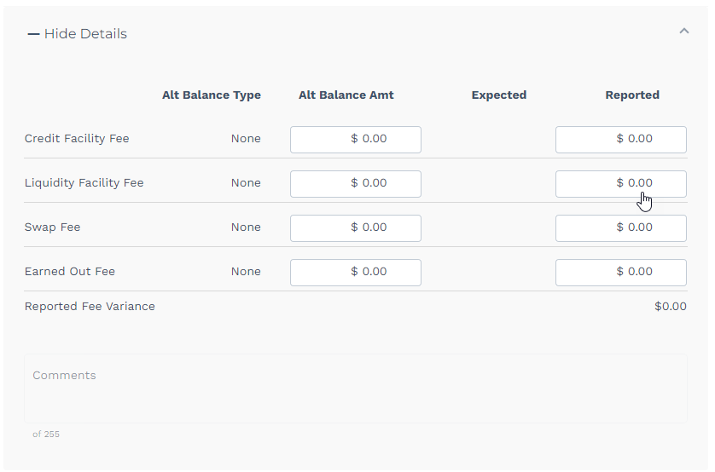

If a reported value isn’t correct, the incorrect field will be outlined in red. Hover over the field to view the error message. The bottom of the page will also show the total number of errors identified when reporting.

Bulk Reporting for Bond Loans
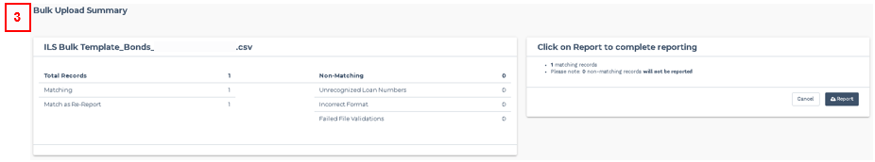

- Click the Bulk Upload button and select Bond Loans Monthly Report from the drop-down.
- Upload a .csv file with the applicable bond information. This file is the same that was used in MSIR – no other file type is accepted.
- After the file is uploaded, the Bulk Upload Summary page will display showing the number of Matching Records and Non-Matching Records. From here, you have two options:
  - Report only the matching records. The non-matching records will remain open.
  - Update the non-matching records prior to reporting and report all records at once.
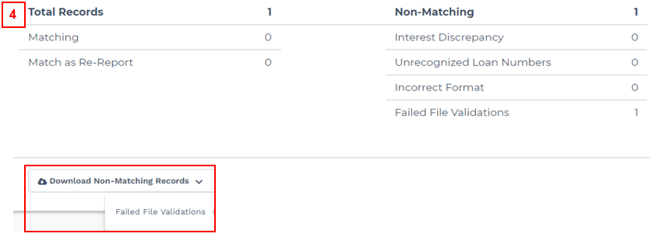
- Non-Matching Records are categorized by Unrecognized Loan Numbers, Incorrect Format and Failed File Validations. Select the applicable Download file to determine which bonds require updates prior to reporting.
- Click the Report button to report on all matching records. The LLR Status of all bond loans will be updated to Reported.

Re-Report on Cash or Bond Loans

Re-Report on a Single Loan
If the data reported (collected prior to the 16th of the current month) is incorrect or requires updates, you can re-report the monthly loan/bond data. Regardless of how the loan was initially reported (single loan reporting or bulk), a single loan can be re-reported directly on the UI.

If applicable, re-report by entering a different value for any of the data reported.

Re-reporting is available until the last day of the reporting window. Note: The reporting window closes on the second to last business day of the month at 8 p.m. Eastern Time.

Re-Report through Bulk
If the data reported (collected prior to the 16th of the current month) is incorrect or requires update, you can re-report the monthly loan/bond data. Even if the loan was previously reported as a single loan, re-reporting can be completed through bulk.

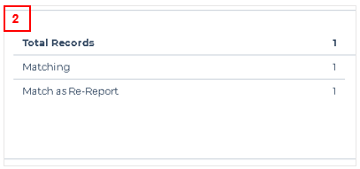
- Upload a new bulk file with the updated data and review the Bulk Upload Summary page.
- Matching Records will appear as Match as Re-Reports and Non-Matching Records will be identified as usual.
- Complete reporting following the usual reporting method, and the initial reporting will be overwritten.

Note that re-reporting is available until the last day of the reporting window.

Report on a Loan in Forbearance
- To report on a cash loan in forbearance, select Dispute Expected from the Report drop-down.
- After the modal displays, enter $0 Lender Actual Principal and $0 Lender Actual Interest, and then select Continue. Please ignore the Discrepancy populated for Principal, which will be equal to the Principal reported.
- The Date Collected field is not required for a loan in forbearance. Note: If a value is entered for Date Collected, the value will not be processed.
- Continue to follow the Dispute Path as usual (next section).

Dispute Expected Interest (Cash Loans)

Tolerance Checks

For Single Loan Reporting

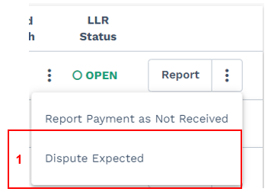
- If Expected Interest displayed is not accurate according to your records, select Dispute Expected from the Report drop-down.
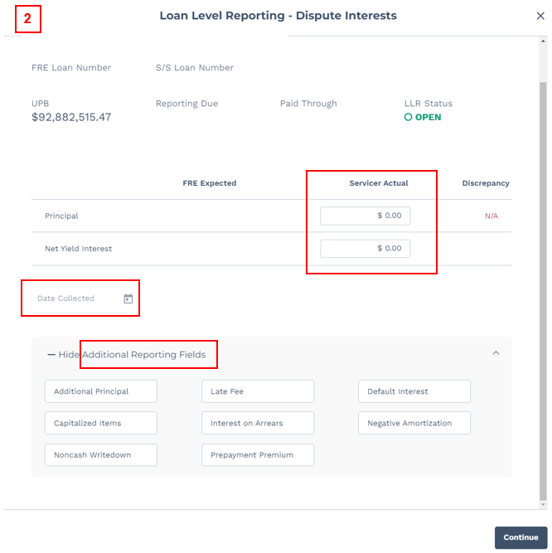

- After the modal displays, enter the required fields: Servicer Actual Principal, Servicer Actual Net Yield Interest, Date Collected and additional reporting fields, if applicable. Select Continue.
  - Please ignore the Discrepancy field populated for Principal, which will be equal to the Principal entered.
- If the Servicer Actual Interest is within tolerance of the FRE Expected Interest, the loan will be accepted. Otherwise, the dispute process will continue (see next page).

For Bulk Reporting

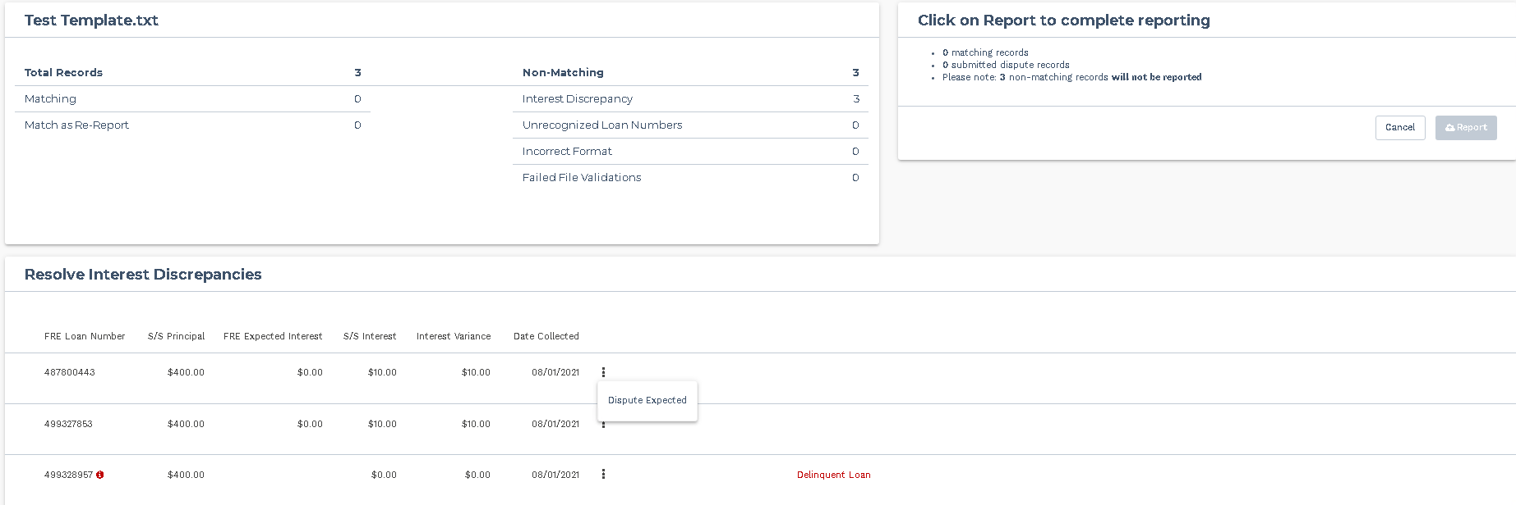

- If interest reported through bulk is within tolerance of the FRE Expected Interest, the loan will be identified as a Matching record.
- If interest reported through bulk is not within tolerance of the FRE Expected Interest, the loan will be identified as a Non-Matching record in the Interest Discrepancy category.
- If FRE Expected Interest displayed is not accurate and S/S Interest is accurate according to your records, select Dispute Expected from the ellipses.

Submitting a Dispute
The following dispute instructions are applicable for both single loan reporting and bulk reporting.

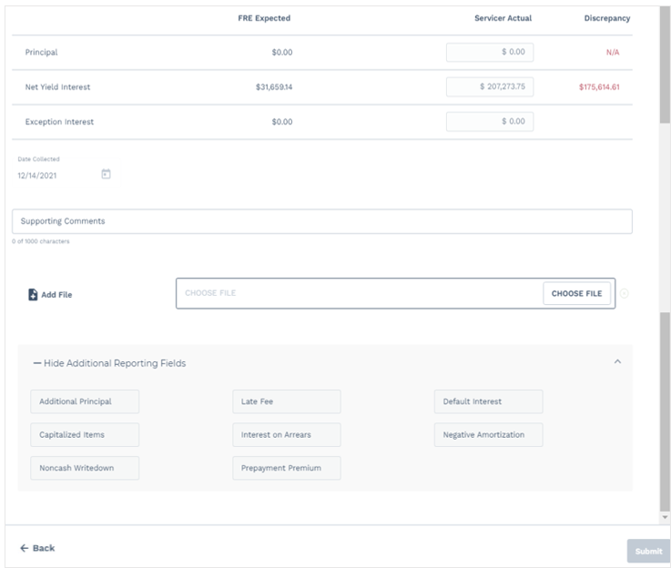

If the interest reported is not within tolerance, the Servicer Actual values will be populated on the Dispute Screen. Ignore the Discrepancy field populated for Principal, which will be equal to the Principal entered. If you need to edit the Servicer Actual values, click the Back button.
- For a loan reported through bulk, the values reported on the bulk template will be populated on this screen.
- Enter Supporting Comments and Supporting Files (PDF only). These are required.
- Complete all fields and click Submit to send the dispute to the Loan Accounting Team.

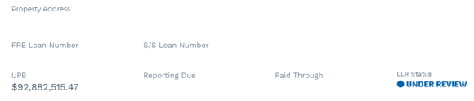

When the dispute is submitted, the LLR status of the loan will update to Under Review. No actions can be taken in myOptigo until the loan is reviewed by a Freddie Mac loan servicing representative.

If the dispute is accepted, the LLR status will update to Reported. If the dispute is rejected, the LLR status will update to Rejected, and the monthly reporting process must be restarted.

The servicer will not receive a notification once the dispute is reviewed. Please check the loan status within 48 hours after submitting a dispute to confirm if the dispute has been accepted or rejected.

Delinquency Reporting

Report on a Delinquent Loan

Through Single Loan Reporting

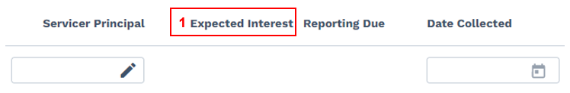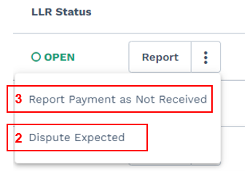

- The Expected Interest field for a delinquent loan will display a blank value.
- To report on the loan, select Dispute Expected from the Report drop-down. This will take you down the dispute path (see Dispute Expected Interest section).
- If the payment for the loan was not received, select Report Payment as Not Received from the Report drop-down.
- Report Payment as Not Received will update the LLR Status to Reported, but the rest of the payment information in myOptigo will remain the same, including the Paid Through date.

Through Bulk Reporting
The following steps are applicable for both cash and bond loans.

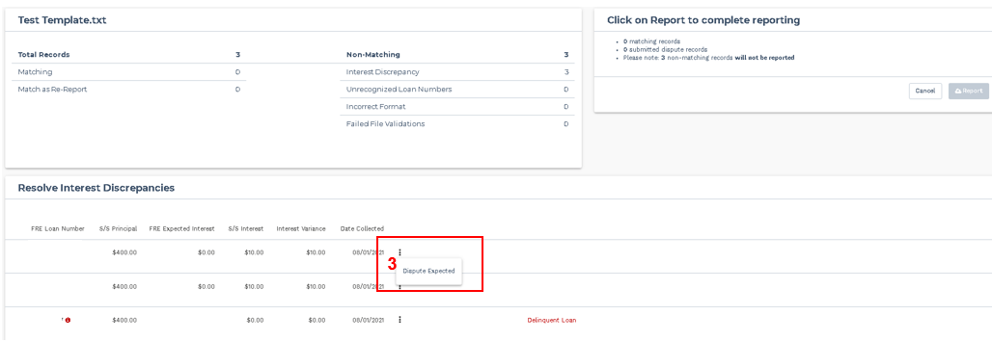

- Add a delinquent loan to the bulk upload file, the same way a normal loan would be reported.
- If a delinquent loan is added to the bulk upload file:
  - It will be identified as a Non-Matching Record in the Interest Discrepancy
  - The FRE Expected Interest will display a blank value
  - Delinquent Loan label will be displayed for identification
- To complete monthly reporting, select Dispute Expected from the ellipses. This will take you down the dispute path (see Dispute Expected Interest section)

Delinquency Reporting/Validation for Cash Loans

Delinquency Reporting
This can be conducted from the Portfolio View page and the Loan Details page (through both the user interface and Bulk Import).

Modify Paid Through Date through the User Interface

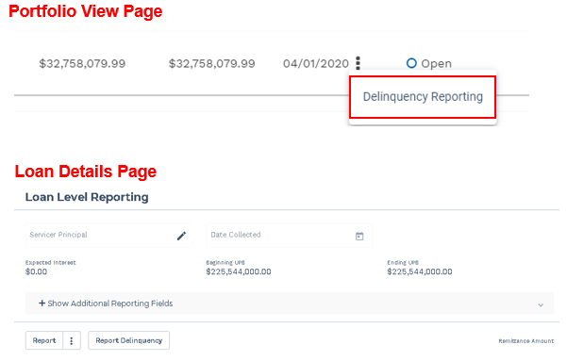
- Delinquency Reporting can be conducted in myOptigo between EOM + 1 and EOM + 3 business days.
- Delinquency Reporting should be conducted for loans that require a modification to the Paid Through Date, based on what was reported during the previous cycle.
- If Payment Not Received was reported during the previous cycle, the Paid Through Date will automatically roll forward if the Delinquency Reporting button is selected. Example: Paid Through Date of 4/1/2020 will become 5/1/2020.
- If monthly reporting was completed during the previous cycle, the Paid Through Date will automatically roll backward if the Delinquency Reporting button is selected. Example: Paid Through Date of 4/1/2020 will become 3/1/2020.
- Once the Paid Through Date is updated, a blue Open checkmark will appear next to the loan on the Portfolio View page, indicating it is ready to be validated.

Modify Paid Through Date through Bulk Import

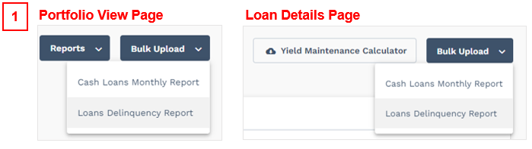

- Click the Bulk Upload button from either page, then click Loans Delinquency Report.
- Upload a .csv file with the delinquency reporting information (same file used for Bonds Delinquency Reporting).
  - Data elements include Freddie Mac Loan Number and EOM DDLPI Paid Through Date.
  - Include only loans that require Delinquency Reporting in the file.
  - Confirm that the data in the file is in the appropriate format.
  - Re-report for Delinquency Reporting is available until EOM + 3 business days.

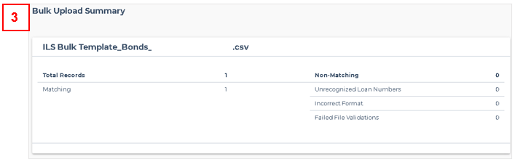

- After the file is uploaded, the Bulk Upload Summary Page will display, showing the number of Matching Records and Non-Matching Records.
- There are two options are this point: (1) Report Matching Records and the Non-Matching Records will remain Open or (2) update Non-Matching Records prior to reporting.
- The Non-Matching Records for Delinquency Reporting are grouped into three separate categories: Unrecognized Loan Numbers, Incorrect Format and Failed File Validations.
  - Failed File Validation checks the EOM_DDLPI date to ensure it is within the acceptable range of +/- 1 month.
  - The max Paid Through Date is current month -1 month (e.g., If today is May (5/1-5/3) and DDLPI is 4/1, min = 3/1/2021, max = 4/1/2021).

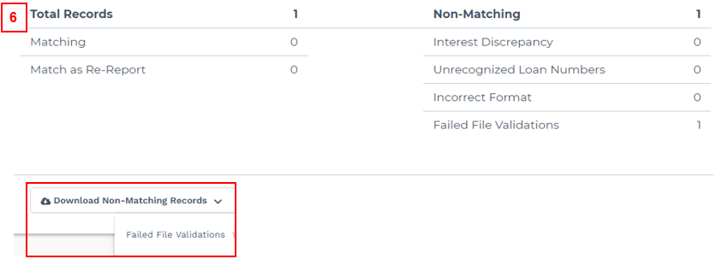

- Select the applicable Download file to determine which loans require updates prior to reporting.
- Click the Report button to report on all Matching Records. The applicable Paid Through Dates will update and reflect a blue checkmark on the Portfolio View page.

Validate Delinquency Reporting
Once changes have been made to the Paid Through Date and if a blue checkmark displays next to it, the Paid Through Date for all loans in the portfolio must be validated.

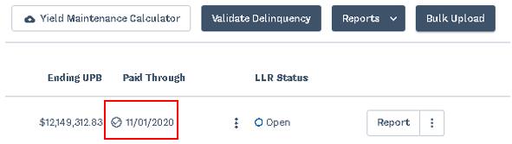

- To validate whether changes were made or not, select the “Validate Delinquency” button.

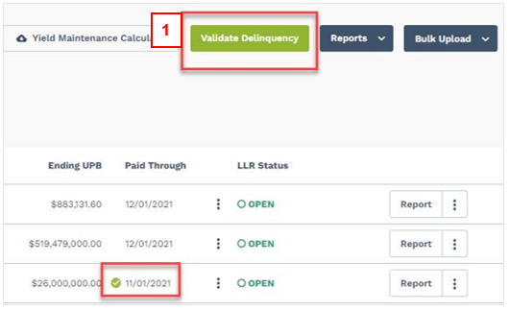

- A confirmation message will pop up. To confirm, select “Certify” and proceed; otherwise select “Cancel” and exit.
  - Once loans are validated, the blue checkmark next to the Paid Through Date for each loan will update to a green checkmark and the Validate Delinquency button will turn green.
  - If no loans are updated, no checkmarks will display, and the Validate Delinquency button will turn green.
  - If any changes to the Paid Through Date are made after the validation has been completed, the applicable checkmarks as well as the Validate Delinquency button will revert to blue checkmarks. To save the updates, you must click the Validate Delinquency button again.

After EOM + 3 when the Delinquency Reporting period ends, the checkmarks will disappear, and the Validate Delinquency button will remain green until the Delinquency Reporting period begins the following month.

Delinquency Reporting/Validation for Bond Loans

Delinquency Reporting
Bond Delinquency Reporting is done through Bulk Upload. Delinquency Reporting can be conducted in myOptigo between EOM + 1 and EOM + 3 (business days).

Reporting should be conducted for bonds that require a modification to the Paid Through date, based on what was reported during the previous cycle.

- Click the Bulk Upload button.
- Upload the bulk template .csv file with the delinquency reporting information.
  - Data elements include Freddie Mac Loan Number & EOM DDLPI Paid Through Date.
  - Include only bonds that require Delinquency Reporting in the file.
  - Confirm that the data in the file is in the appropriate format.
  - Re-report for Delinquency Reporting is available until EOM + 3 business days.
- After the file is uploaded, the Bulk Upload Summary Page will display showing the number of Matching Records and Non-Matching Records.
- There are two options are this point: (1) Report Matching Records and the Non-Matching Records will remain Open or (2) update Non-Matching Records prior to reporting.
  - The Non-Matching Records for Delinquency Reporting are grouped into two separate categories: Unrecognized Loan Numbers and Incorrect Format.
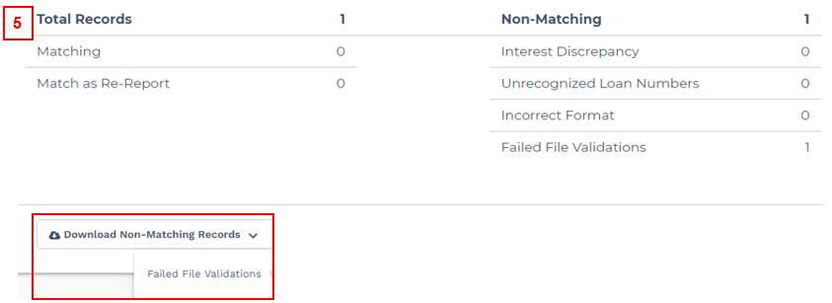
- Select the applicable Download file to determine which bonds require updates prior to reporting.
- Click the Report button to report on all matching records. The applicable Paid Through Dates will update and reflect a blue checkmark on the Portfolio View page.

Validate Delinquency Reporting
Once changes have been made to the Paid Through date and if a blue checkmark displays next to it, the Paid Through date for all bonds in the portfolio must be validated.

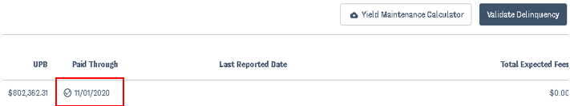

- To validate whether changes were made or not, select the “Validate Delinquency” button.

- A confirmation message will pop up. To confirm, select “Certify” and proceed; otherwise select “Cancel” and exit.
  - Once bonds are validated, the blue checkmark next to the Paid Through date for each loan will update to a green checkmark and the Validate Delinquency button will turn green.
  - If no bonds are updated, no checkmarks will display, and the Validate Delinquency button will turn green.
  - If any changes to the Paid Through date are made after the validation has been completed, the applicable checkmarks as well as the Validate Delinquency button will revert to blue checkmarks. To save the updates, you must click the Validate Delinquency button again.

After EOM + 3 when the Delinquency Reporting period ends, the checkmarks will disappear, and the Validate Delinquency button will remain green until the Delinquency Reporting period begins the following month.

Payoff/Disposition

Yield Maintenance Calculator

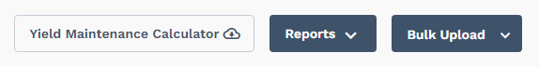

Servicers can download the Yield Maintenance Calculator from the Portfolio Summary page, Portfolio View page or Loan Details page. Once applicable data elements are entered in the calculator, the prepayment penalty will display.

Report a Cash Payoff (Code 61)
Payoffs can be reported from the Portfolio View page or the Loan Details page. The following instructions are for reporting a Cash Payoff (code 61) through the user interface.

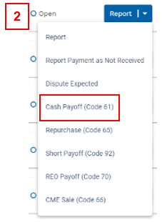

- To report a payoff, contact the Loan Accounting Team to create a payoff record.
  - Contact the team with payoff information at least one day prior to the reporting deadline.
  - Monthly reporting must be completed prior to reporting a payoff.
- Select Cash Payoff (Code 61) from the Report drop-down.
- Payoff data will be pre-populated from the payoff record. Note: If this data is incorrect, contact your Freddie Mac Loan Servicing representative.

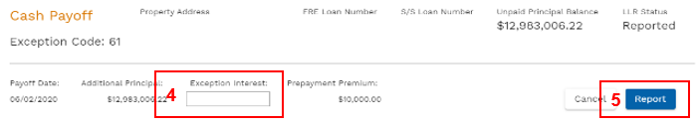

- Enter Exception Interest if applicable.
- Click Report to submit the payoff.

Report a Repurchase (Code 65)

Payoffs can be reported from the Portfolio View page or the Loan Details page. The following instructions are for reporting a repurchase (Code 65) through the user interface.
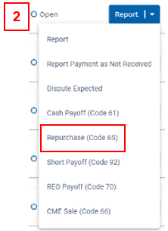

- To report a payoff, contact the Loan Accounting Team to create a payoff record.
  - Contact the team with payoff information at least one day prior to the reporting deadline.
  - Monthly reporting must be completed prior to reporting a payoff.
- Select Repurchase (Code 65) from the Report drop-down.
- Payoff data will be pre-populated from the payoff record. Note: If this data is incorrect, contact your Freddie Mac Loan Servicing representative.

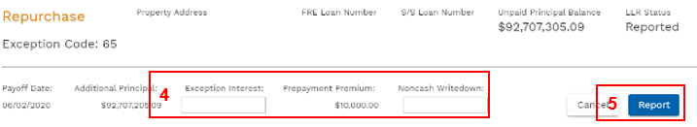
- Enter Exception Interest and Noncash Writedown, if applicable. Ending UPB must equal zero (0).
- Click Report to submit the payoff.

Report a Short Payoff

Payoffs can be reported from the Portfolio View page or the Loan Details page. The following instructions are for reporting a Short Payoff (Code 92) through the user interface.

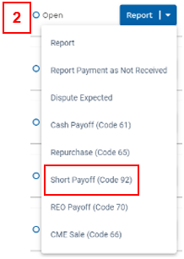

- To report a payoff, contact the Loan Accounting Team to create a payoff record.
  - Contact the team with payoff information at least one day prior to the reporting deadline.
  - Monthly reporting must be completed prior to reporting a payoff.
- Select Short Payoff (Code 92) from the Report drop-down.
- Payoff data will be pre-populated from the payoff record. Note: If this data is incorrect, contact your Freddie Mac Loan Servicing representative.
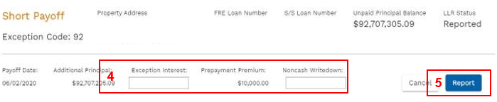
- Enter Exception Interest and Noncash Writedown, if applicable. Ending UPB must equal zero (0).
- Click Report to submit the payoff.

Report an REO Payoff (Code 70)

Payoffs can be reported from the Portfolio View page or the Loan Details page. The following instructions are for reporting an REO Payoff (Code 70) through the user interface.
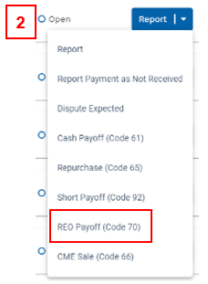

- To report a payoff, contact the Loan Accounting Team to create a payoff record.
  - Contact the team with payoff information at least one day prior to the reporting deadline.
  - Monthly reporting must be completed prior to reporting a payoff.
- Select REO Payoff (Code 70) from the Report drop-down.
- Payoff data will be pre-populated from the payoff record. Note: If this data is incorrect, contact your Freddie Mac Loan Servicing representative.

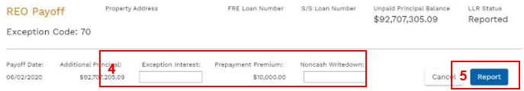
- Enter Exception Interest and Noncash Writedown, if applicable. Ending UPB must equal zero (0).
- Click Report to submit the payoff.

Report a CME Sale (Code 66)
Payoffs can be reported from the Portfolio View page or the Loan Details page.

The following instructions are for reporting a CME Sale (Code 66) through the user interface.

Note: Servicer will be contacted by the Loan Accounting Team when loans are part of a CME sale. Monthly reporting must be completed prior to reporting a payoff.
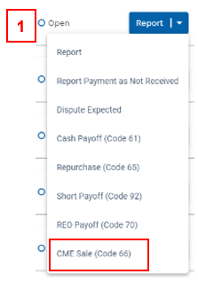
- Select CME Sale (Code 66) from the Report drop-down.

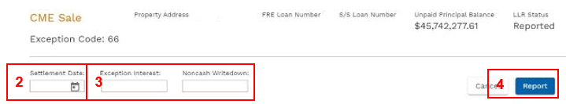
- Enter the Settlement Date. Note that the payoff settlement date must equal the settlement date of the sale.
- Enter Exception Interest and Noncash Writedown, if applicable. Ending UPB must equal zero (0).
- Click Report to submit the payoff.

Dispute Exception Interest on a Single Loan
The exception interest will be validated by the Investor Reporting Team. The ability to dispute Exception Interest during a loan payoff is only for loans in REPORTED status.

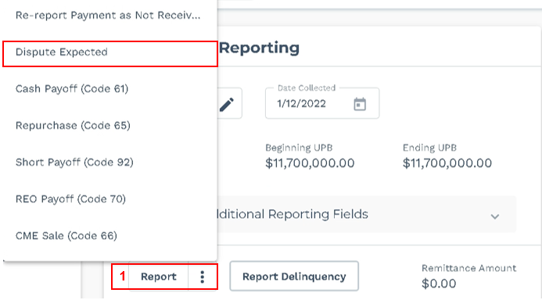

- To dispute the Exception Interest value, click the Report drop-down on the Loan Details page.
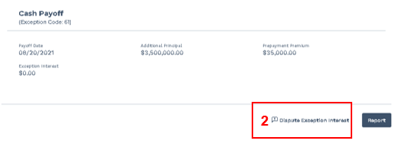
- Select Dispute Exception Interest checkbox at the bottom of the Payoff Report view.
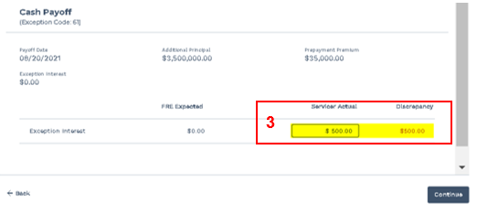
- Enter Servicer Actual Exception Interest value and review the discrepancy amount.

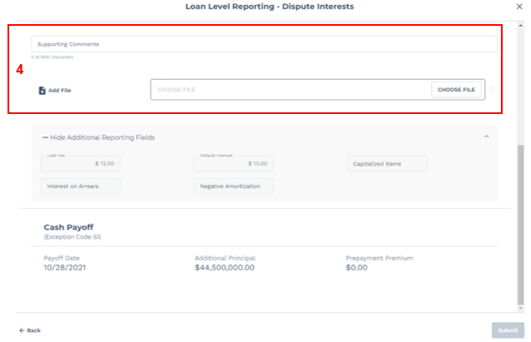

- Enter Supporting Comments and Supporting Files (PDF only). Both are required.
- When all fields are completed, click Submit to send the dispute to the Loan Accounting queue.

Please note:
- When the dispute is submitted, the LLR status of the loan will update to Under Review – Pending Payoff.
- No actions can be taken in myOptigo until the loan is reviewed by a Freddie Mac loan servicing representative.
- If the dispute is accepted, the LLR status will update to Reported Paid Off.
- If the dispute is rejected, the LLR status will update to Rejected – Pending Payoff, and the payoff reporting process must be restarted.
- Notification will not be provided once the dispute is reviewed. Please check the loan status in myOptigo after submitting a dispute to confirm if the dispute has been accepted or rejected. You should see a status update within 48 hours.

Report a Loan Payoff through Bulk in One Transaction

Loan payoffs are conducted through bulk in the same transactions as monthly reporting. The payoff will be validated against the payoff record.

Note that this function is only available for loans in an OPEN status.
- To report a payoff, contact the Loan Accounting Team to create a payoff record
- Upload a bulk report (.txt file) with all applicable monthly reporting and payoff data elements (follow the same Bulk Reporting approach as for Monthly Reporting found in this section).
  - The payoff data elements will be validated against the payoff record. Data elements include: Exception Code, Transaction Date, Additional Principal, Prepayment Premium, Ending UPB
  - Net Yield Interest must equal Expected Interest. Exception Interest must be equal to the Freddie Mac Exception Interest. See the next section for more information on how to dispute Exception Interest through Bulk Reporting.

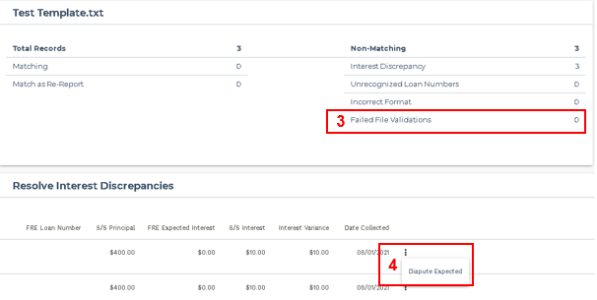

- If the data elements reported are different from the data elements expected, the loan will be identified as a “Non-Matching” record under the Failed File Validations category.
- If Expected Interest displayed is not accurate according to your records, select the ellipsis (three black dots) and select Dispute Expected. Include the Exception Code applicable to the payoff: 61, 65, 66, 70, or 92
- After reporting a payoff, no additional actions can be taken.

Report a Loan Payoff through UI in One Transaction

Loan payoffs can be conducted through the user interface in the same transaction as monthly reporting. The payoff will be validated against the payoff record.

Note that this function is only available for loans in an OPEN status.
- To report a payoff, contact the Loan Accounting Team to create a payoff record.

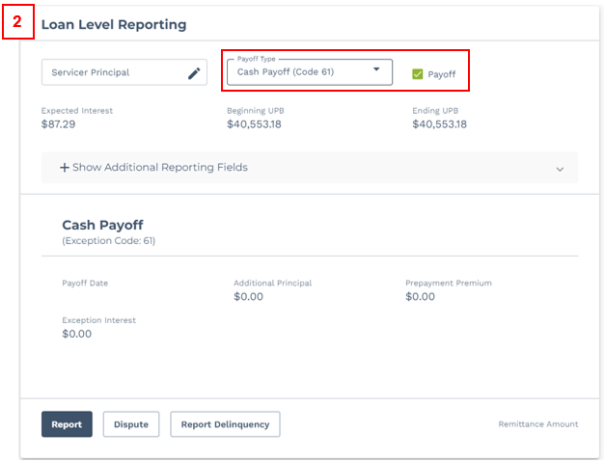

- On the Loan Details page, select the Payoff Type from the drop-down and the Payoff checkbox. In this example, you see a Cash Payoff (Code 61).

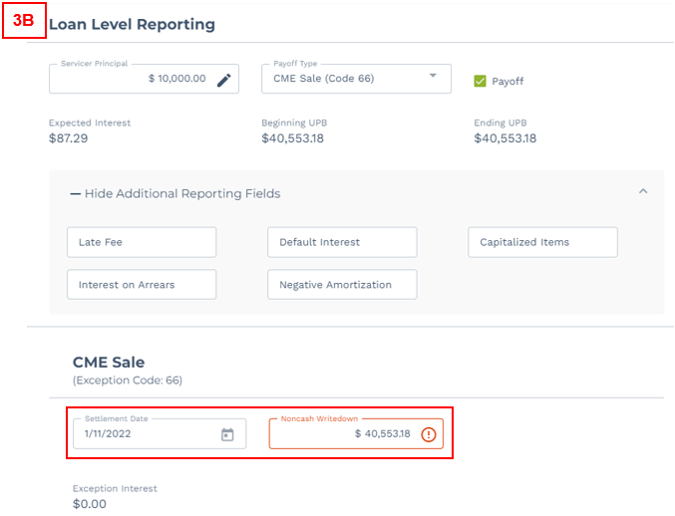
- Enter Servicer Principal and any additional reporting fields.
  - For all other Payoff Types, you must enter the Noncash Writedown.
  - If you select CME Sales (Code 66) from the Payoff Type drop-down, you will need to enter the Settlement Date in addition to the Noncash Writedown.

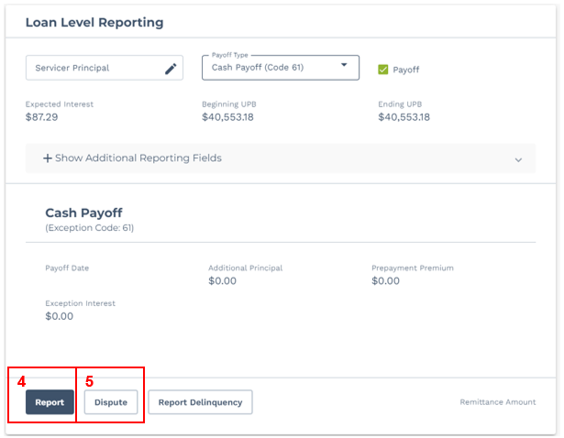

- Click the Report button if you agree with the displayed Expected Interest and Exception Interest. The LLR Status will change to REPORTED PAID OFF.
- Alternatively, to dispute the displayed Expected Interest or Exception Interest, select the Dispute button.

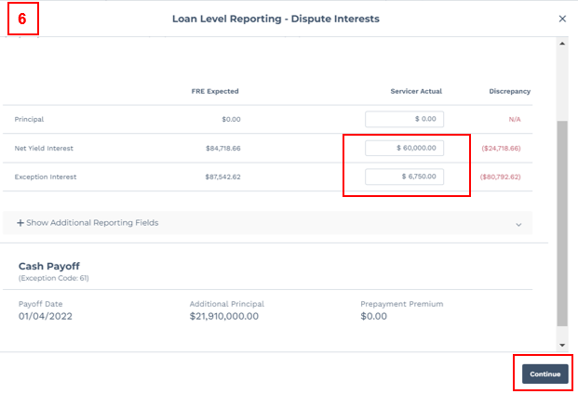
- Enter Servicer Actual Net Yield Interest and Exception Interest. Review the discrepancy amounts, then click continue.

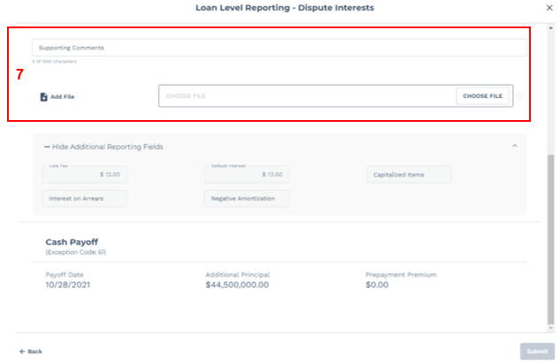

- Enter Supporting Comments and Supporting Files (PDF only). Both are required.
- Click Submit to send the dispute to the Loan Accounting queue.

Please note:
- When the dispute is submitted, the LLR status of the loan will update to Under Review – Pending Payoff.
- No actions can be taken in myOptigo until the loan is reviewed by a Freddie Mac loan servicing representative.
- If the dispute is accepted, the LLR status will update to Reported Paid Off.
- If the dispute is rejected, the LLR status will update to Rejected – Pending Payoff, and the payoff reporting process must be restarted.
- Notification will not be provided once the dispute is reviewed. Please check the loan status in myOptigo after submitting a dispute to confirm if the dispute has been accepted or rejected. You should see a status update within 48 hours.

Dispute Net Yield/Exception Interest through Bulk Payoff
Exception interest will be validated by the Investor Reporting Team. Note that this function is only available for loans in an OPEN status.

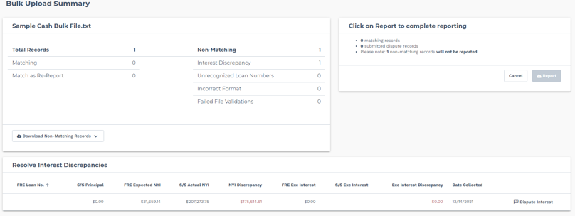
- Follow the same steps to dispute expected interest for single cash loans. If the dispute is not within tolerance, the Servicer Actual values will be populated on the Dispute Screen. Please ignore the Discrepancy populated for Principal, which will be equal to the Principal entered.
- To modify the values, select the ellipses menu to the right of the Date Collected field.
- Enter Supporting Comments and Supporting Files (PDF only). Both are required.
- When all fields are completed, click Submit to send the dispute to the Loan Accounting queue.

Please note:
- When the dispute is submitted, the LLR status of the loan will update to Under Review – Pending Payoff.
- No actions can be taken in myOptigo until the loan is reviewed by a Freddie Mac loan servicing representative.
- If the dispute is accepted, the LLR status will update to Reported Paid Off.
- If the dispute is rejected, the LLR status will update to Rejected, and the monthly reporting/payoff process must be restarted.
- Notification will not be provided once the dispute is reviewed. Please check the loan status in myOptigo after submitting a dispute to confirm if the dispute has been accepted or rejected. You should see a status update within 48 hours.

Report a Bond Payoff (Code 51) in UI
This details how to report on a single bond payoff through the user interface. Note that payoff reporting on a single bond can only be completed from the Bond Details page.

When reporting a payoff for a bond loan, please note the following conditions (where applicable):
- Exception Code checkbox must be selected in order to proceed.
- Transaction Date must equal the Payoff Date.
- Loan Additional Principal must equal the Payoff Principal.
- Principal Reserve Balance, Principal Sinking Balance, Early Interest Balance, and Ending UPB must be $0 when payoff is reported.
- Loan Prepayment Premium must equal Payoff Prepayment Premium.
- Payoffs can be viewed in myOptigo for up two months after the payoff date.

Please note: The Reporting Month of the payoff will continue to display the current month, rather than the month in which the payoff was reported.

Report a Bond Payoff (Code 51) through Bulk
Bond payoffs are conducted through bulk in the same transactions as Monthly Reporting. The bond payoff will be validated against the payoff record.

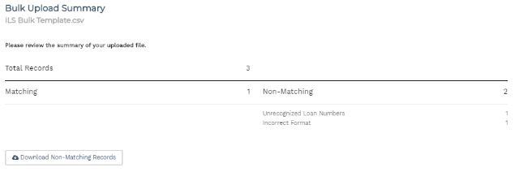
- To report a payoff, contact the Loan Accounting Team to create a payoff record.
- Upload a bulk report with all applicable monthly reporting and payoff data elements. The payoff data elements will be validated against the payoff record.
  - Data elements include: Exception Code, Transaction Date, Additional Principal, Prepayment Premium, Ending UPB.
  - For payoffs with transaction date prior to the 15th, report the payoff data and monthly reporting data in one file.
  - For payoffs with transaction date after the 15th, report monthly reporting with data collected prior to the 15th and report payoff data in a separate file with the appropriate transaction date.
- After reporting a payoff, no additional actions can be taken.
  - If a bond is added to a bulk upload template after it has been paid off, the bond will be identified as a non-matching record in the Failed File Validations category.

Payoffs can be viewed in myOptigo for up two months after the payoff date.

Note: The Reporting Month of the payoff will continue to display the current month, rather than the month in which the payoff was reported.

Report a Loan Curtailment through UI

The following instructions are for reporting a Curtailment through the user interface.

Current Cycle:

- To report a Curtailment, contact the “Multifamily Payoff Team” to create a Curtailment record.
Note: When Loan Accounting Team creates the Curtailment record, make sure the date in the record should be in the range of Curtailment reporting cycle.
  - Example 1: If the date is between January 16 and Feb 15, reported curtailment amount will apply to Feb cycle.
  - Example 2: If the date is between Feb 16 and March 15, reported curtailment amount will apply to March cycle.

- Make sure to select Current cycle from the Cycle drop-down
  - Example: If today is 02/12/2023, the cycle should be 02/2023.

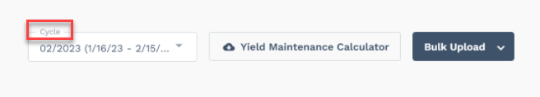

- Enter the details in below Editable fields:
  - Servicer Principal. Note: By design, Curtailment is part of Monthly reporting in ILS and servicer principal is a required value. If monthly payment is not received enter 0.00 and re-report with correct amount once the monthly payment is received.
  - Date Collected. Note: Date Collected can range from the 16th of the prior month to the 15th of the current month and cannot be greater than today’s date (Transaction Date).
  - Additional Principal
  - Prepayment Premium

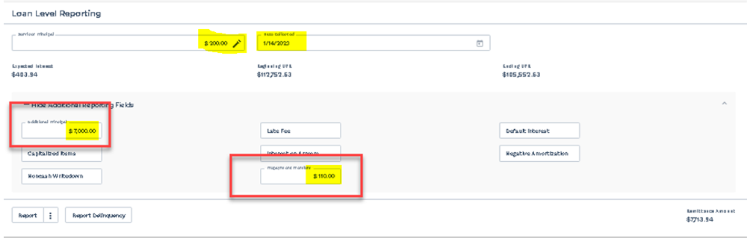

- Additional Principal and Prepayment Premium values should match with Curtailment record. If you get an error, contact your Freddie Mac Loan Servicing representative.
- Click “Report” to submit the Curtailment.
- LLR Status changes to “Reported”.

Note:
- Curtailment should be submitted as part of the monthly reporting for current cycle.
- If a loan is delinquent, then you cannot report curtailment.

Future Cycle:

- To report a Curtailment, contact the “Multifamily Payoff Team” to create a Curtailment record.
Note: When Loan Accounting Team creates the Curtailment record, make sure the date in the record should be in the range of Curtailment reporting cycle.
  - Example 1: If the date is between January 16 and Feb 15, reported curtailment amount will apply to Feb cycle.
  - Example 2: If the date is between Feb 16 and March 15, reported curtailment amount will apply to March cycle.

- Make sure to select Future cycle from the Cycle drop-down
  - Example: If today is 02/21/2023, the cycle should be 03/2023.
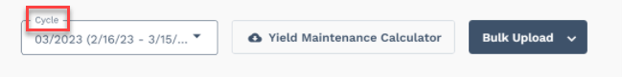
- Enter the details in below fields:
- Date Collected. Note: Date Collected can range from the 16th of the current month to the 15th of the following month and cannot be greater than today’s date (Transaction Date).
- Additional Principal
- Prepayment Premium

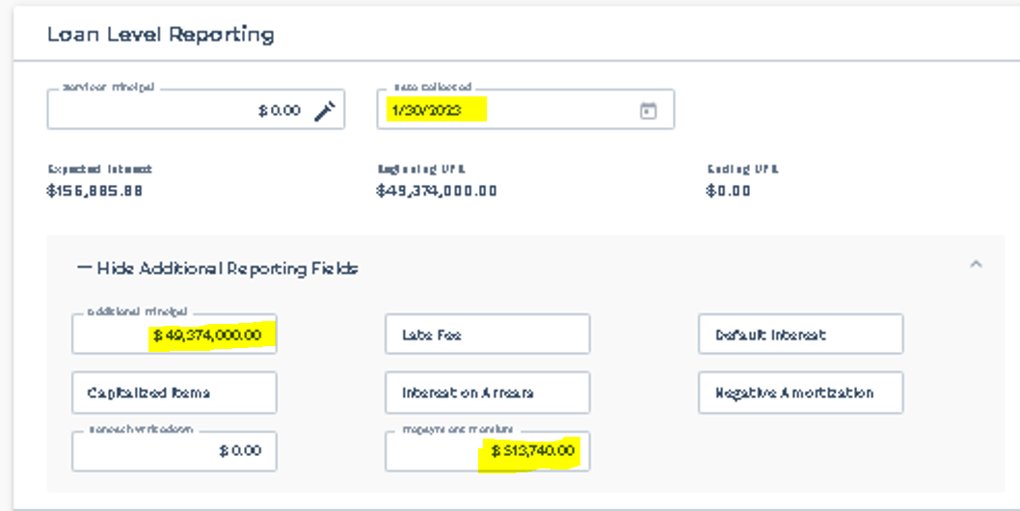

- Additional Principal and Prepayment Premium values should match with Curtailment record. If you get an error, contact your Freddie Mac Loan Servicing representative.
- Click “Report” to submit the Curtailment.
- LLR Status changes to “Reported”.
Note:
- If a loan is reported as disputed for current cycle, then you can report curtailment for future cycle.
- If a loan is delinquent, then you cannot report curtailment.

Report a Loan Curtailment through Bulk in One Transaction

Loan Curtailment are conducted through bulk in the same transactions as monthly reporting for current cycle. The Curtailment will be validated against the Curtailment record.

Current Cycle:
- To report a Curtailment, contact the “Multifamily Payoff Team” to create a Curtailment record.
Note: When Loan Accounting Team creates the Curtailment record, make sure the date in the record should be in the range of Curtailment reporting cycle.
  - Example 1: If the date is between January 16 and Feb 15, reported curtailment amount will apply to Feb cycle.
  - Example 2: If the date is between Feb 16 and March 15, reported curtailment amount will apply to March cycle.

- Upload a bulk report (.txt file) with all applicable monthly reporting and Curtailment information (Additional Principal and Prepayment Premium) for current cycle (follow the same Bulk Reporting approach as for Monthly Reporting found in this section).
Note: By design, Curtailment is part of Monthly reporting in ILS for current cycle. If monthly payment is not received, report only curtailment data. Once the monthly payment is received, re-reporting through bulk should include all the other previously reported values.
- Additional Principal and Prepayment Premium values should match with Curtailment record. If the values don’t match, the loan will be identified as a “Non-Matching” record under the Failed File Validations category. Contact your Freddie Mac Loan Servicing representative if the data need to be corrected/missing curtailment record.
- Click “Report” to submit the Curtailment.
- LLR Status changes to “Reported”.

Note:
- If a loan is delinquent, then you cannot report curtailment.

Future Cycle:

- To report a Curtailment, contact the “Multifamily Payoff Team” to create a Curtailment record
Note: When Loan Accounting Team creates the Curtailment record, make sure the date in the record should be in the range of Curtailment reporting cycle.
  - Example 1: If the date is between January 16 and Feb 15, reported curtailment amount will apply to Feb cycle.
  - Example 2: If the date is between Feb 16 and March 15, reported curtailment amount will apply to March cycle.
- Upload a bulk report (.txt file) with all the below applicable Curtailment information:
  - FMLoan
  - Transaction Date. Note: Should be between 16th of current month to 15th of future month and not greater than today’s date (Transaction Date).
  - Additional Principal
  - Prepayment Premium
- Additional Principal and Prepayment Premium values should match with Curtailment record. If the values don’t match, the loan will be identified as a “Non-Matching” record under the Failed File Validations category. Contact your Freddie Mac Loan Servicing representative if the data need to be corrected/missing curtailment record.
- Click “Report” to submit the Curtailment.
- LLR Status changes to “Reported”.

Note:
- If a loan is reported as disputed for current cycle, then you can report curtailment for future cycle.
- If a loan is delinquent, then you cannot report curtailment.

Report Multiple Curtailments in a Cycle

- To report a new Curtailment, contact the “Multifamily Payoff Team” to create a Curtailment record. Add all the details from the previous curtailment to the current curtailment record.
  - Example:
Previous Curtailment Record | Current Curtailment Record
Additional Principal = $100.00 | Additional Principal = $100.00 + $200.00 (new curtailment value)
Prepayment Premium = $200.00 | Prepayment Premium = $200.00 + $100.00 (new curtailment value)

- To report new curtailment through UI, please follow “Report a Loan Curtailment through UI” found in this section
- To report new curtailment through Bulk, please follow “Report a Loan Curtailment through Bulk in One Transaction” found in this section

Cash/Bond Loan History

Loan History

View up to seven years of loan activity history in myOptigo®. Certain loan history may not be available depending on when the loan was funded. For example:

- If the loan was funded in 2010 and you are accessing the loan in the November 2023 cycle, then you can only view cycles from 11/01/2016 through 11/01/2023.

- If the loan was funded in January 2020 and you are accessing the loan in the November 2023 cycle, then you can view all cycles from 01/01/2020 through 11/01/2023.

You can access loan history from the Search Bar or Portfolio View Screen.

Access Through Search Bar

To navigate Cash Loan History using the search bar, enter the FRE Loan number, S/S Loan number or property address in the search bar and click View History.

Note: Press ‘Enter’ on the keyboard to apply the search functionality to the option highlighted in gray.

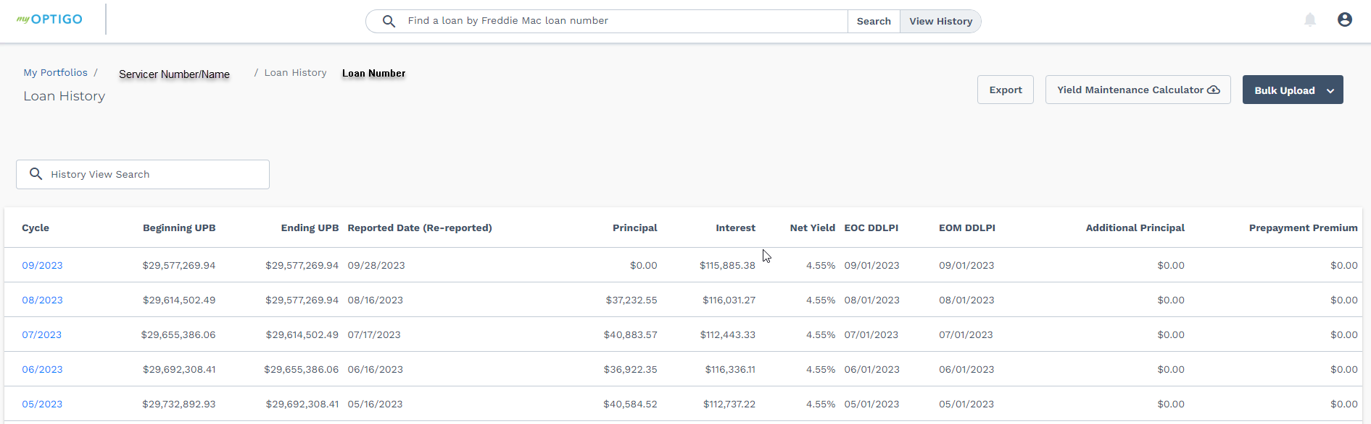
Loan history view for active Cash Loans

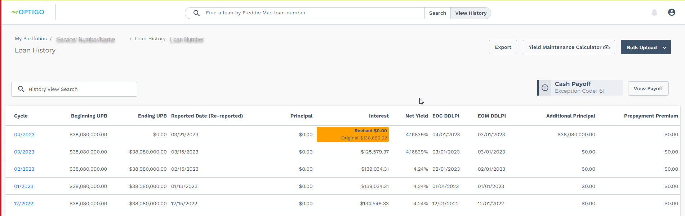
Loan history view for paid off Cash Loans

Access through Portfolio View Screen

To access the Cash Loan History from the Portfolio View screen, follow the steps below.

- View loans associated by Total Active, Open, Rejected, Under Review, Reported and Paid off loans by clicking the hyperlink under label or count.

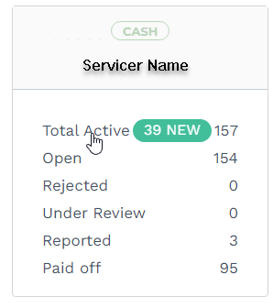
1

- The Portfolio screen will display a View History button for each category. Click the View History button to access up to seven years of history depending on when the loan was funded.

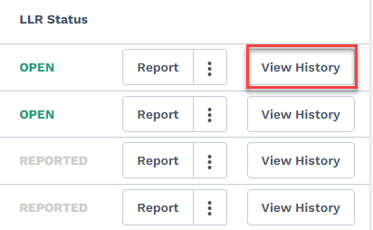
2

- To view the details for a specific cycle, click the date in the Cycle column.
3

Note: Users can export the history or loans in a portfolio to a csv file by clicking the Export button.

Bond History

View up to seven years of bond activity history in myOptigo. Certain bond history may not be available depending on when the bond was funded. For example:
- If the bond was funded in 2010 and you are accessing the bond in the March 2024 cycle, then you can only view cycles from 03/01/2017 through 03/01/2024.
- If the bond was funded in January 2020 and you are accessing the bond in the March 2024 cycle, then you can view all cycles from 01/01/2020 through 03/01/2024.

You can access loan history from the Search Bar or Portfolio View Screen.

Access Through Search Bar

To navigate Bond Loan History using the search bar, enter the Freddie Mac Bond Loan number or Seller/Servicer Loan number in the search bar. Click View History.

Note: Press ‘Enter’ on the keyboard to apply the search functionality to the option highlighted in gray.

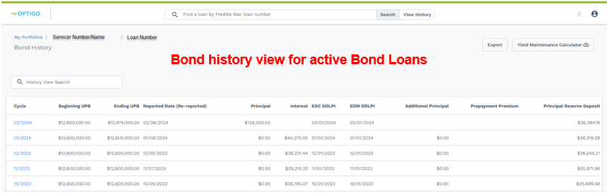

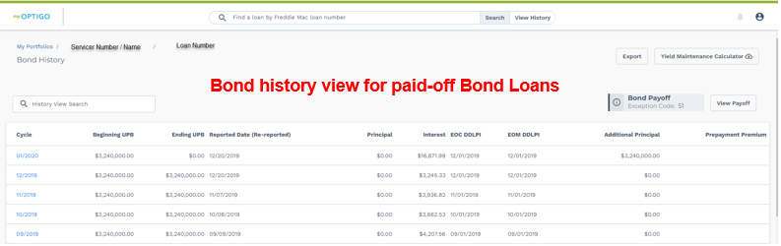

Access Through Portfolio View Screen

To access the Bond Loan History from the Portfolio View screen, follow the steps below.

- View bond loans associated by Total Active, Open, Reported and Paid off loans by clicking the hyperlink under label or count.

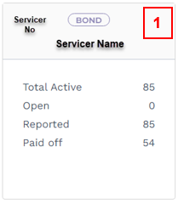

- The Portfolio screen will display a View History button for each category. Click the View History button to access up to seven years of history depending on when the loan was funded.

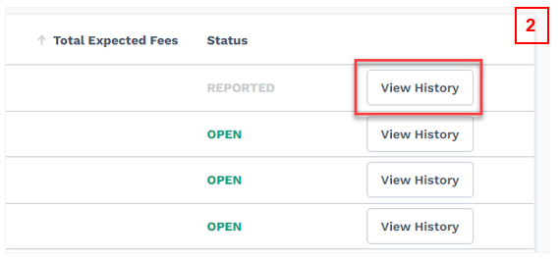

- To view the details for a specific cycle, click the date in the Cycle column.

Note: Users can export the history or loans in a portfolio to a CSV file by clicking the Export button.

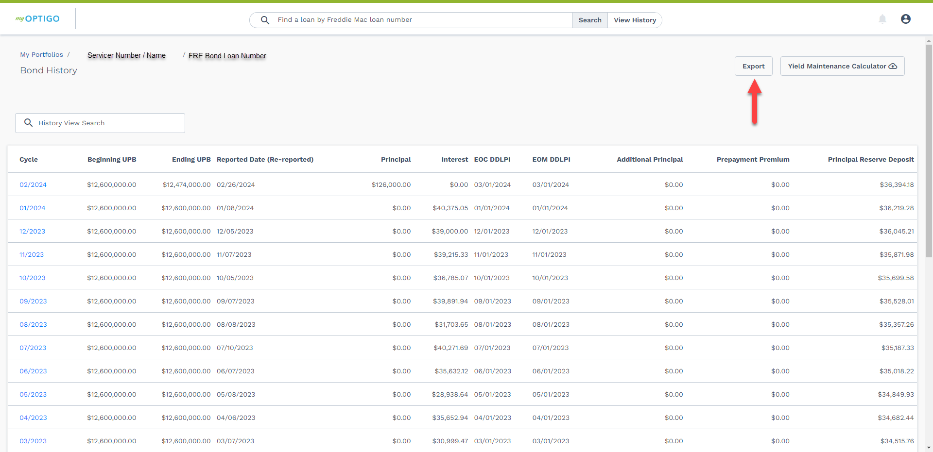
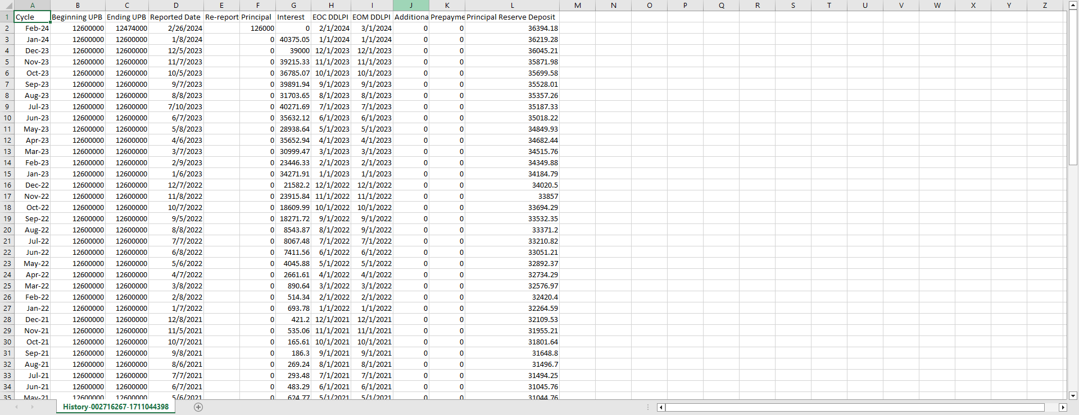

Reports
Servicer Reports (previously known as MSIR+ Reports) are available on the Portfolio Summary and Portfolio View pages. Use the following instructions to download reports.

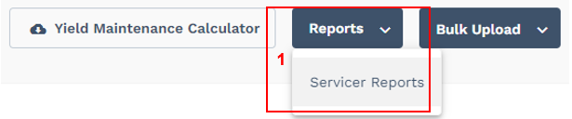
- Select the Reports button at the top right of the Portfolio Summary or Portfolio View page.
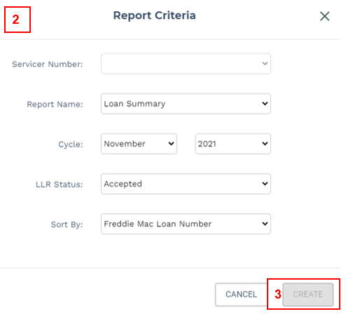

- In the pop-up window, select the appropriate Servicer Number, Report Name, Cycle, LLR Status and Sort By options. Under the Report Name category, you’ll find these types of reports:
  - Loan Summary
  - Remittance Due
  - Trial Balance
  - ARM Periodic
  - EOM DDLPI
  - Bond Summary
- Click the Create button and the report will be downloaded to your computer.

If you have any issues, please reach out to your Loan Accounting representative.

Technical Help
If you encounter a technical issue while using the investor reporting features in myOptigo, contact the Multifamily Service Desk or your system administrator.

We recommend using the Google Chrome or Microsoft Edge internet browsers to access myOptigo for the best user experience.

If you have any suggestions or would like to collaborate as Freddie Mac Multifamily continues transforming, please send an email to the Multifamily Feedback mailbox.

Appendix

Bulk Upload Templates and Specifications

Please find the templates and data field specifications for loans and bonds each in the below files:
- Loan Bulk Upload Template
- Loan Bulk Upload Specifications
- Bonds Bulk Upload Template
- Bonds Bulk Upload Specifications

Ex: Report a Loan Payoff through Bulk in One Transaction

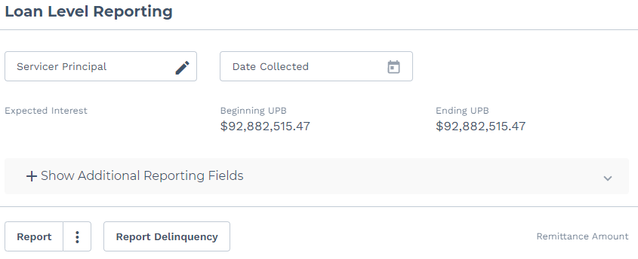

Bulk File Example

#BEGINLLR
FMLoan=123456789
SSLoan=987654321
SSNumber=123456
ReportingMethod=AA
EOCDDLPI=09/01/2020
Period=09/2020
ExceptionCode=61 (Must equal 61, 66, 65, 70, 92)
TransactionDate=09/07/2020 (Must equal payoff date)
TransactionNumber=1
ActualPrincipal=79.99 (Ending UPB must equal 0)
ActualNetYieldInterest=5716873.33 (Must equal Expected Interest)
AdditionalPrincipal=32758000.00 (Must equal expected payoff principal amount and Ending UPB must equal 0)
NoncashWritedown=0.00 (Ending UPB must equal 0)
PrepaymentPremium=1000.00 (Must equal expected prepayment premium)
ExceptionInterest=2000.00
DefaultInterest=100.00
LateFee=200.00
#ENDLLR

When to Expect Reporting on Newly Funded Loans

Funding Date is within the current month
Ending UPB at accounting cutoff | Reporting and Remitting Required
Equals funding balance | Monthly Reporting should not be completed for loans that were funded (been purchased by Freddie Mac) in the same month
Does not equal funding balance | Principal is due, but no interest is due (Expected Interest will be $0.00)

Funding Date is between the 16th and end of month of the prior month
Ending UPB at accounting cutoff | Reporting and Remitting Required
Equals funding balance | One month’s interest (equal to the Expected Interest)
Does not equal funding balance | Principal reduction and one month’s interest

To report payoffs for newly funded loans that are being paid off, there are two options:
- Recommended Approach: For loans with an LLR status in OPEN, report a Payoff through bulk
- For loans with an LLR status in REPORTED, the loan must be reported in myOptigo prior to reporting the payoff

