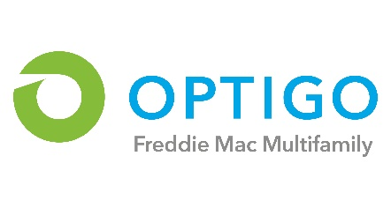
Optigo® Lender’s Fee Certification – Conventional & Targeted Affordable

Borrower:
Optigo Lender:
Date of Certification:

In connection with the Mortgage loan identified above (the “Loan”), Optigo Lender represents and warrants to Freddie Mac that unless otherwise indicated below (i) no amount of the servicing fee or securitization compensation on this Loan has been or will be paid to anyone other than Optigo Lender in connection with the origination of the Loan (other than servicing fees paid in connection with a Freddie Mac approved sub-servicing agreement), and (ii) this Loan transaction is not subject to any “master” or other agreements related to Broker/Correspondent compensation that have not been disclosed to Freddie Mac. “Broker/Correspondent”* and other capitalized terms not defined herein have the meaning given to such terms in the Freddie Mac Multifamily Seller/Servicer Guide.
Optigo Lender further represents and warrants to Freddie Mac that all fees, commissions or other amounts paid or payable (currently or on a contingent basis), by Optigo Lender to the Broker/Correspondent (including amounts paid outside of closing) in connection with or related to this Loan have been disclosed to Freddie Mac.
* For the purposes of this Certification, the references to Broker/Correspondent are also deemed to include a brokerage/correspondent firm or broker entitled to compensation in connection with the Loan pursuant to an agreement with the Optigo Lender, even if the Broker/Correspondent has not been engaged by or on behalf of the Borrower in connection with the Loan. (If applicable, complete the “Other payments” row below.)

Third-party Mortgage Broker/Correspondent: | Firm: ________________________  Individual: ____________________
Origination Fee Paid by or on behalf of Borrower:  Portion of Origination Fee paid to Broker/Correspondent: | ____%, or $________ if fixed fee  ____%, or $________ if fixed fee
Optigo Lender Buy Up Fee (%):  Portion of Buy Up Fee paid to Broker/Correspondent: | ___%  ____%, or $________ if fixed fee
Other payments to Broker/Correspondent, not included above: | ____%, or $________ if fixed fee
Total payments to Broker/Correspondent: | ____%, or $________ if fixed fee

The servicing fee and/or Freddie Mac securitization compensation applicable to this Loan will determine, or will be a factor in determining, Broker/Correspondent compensation, in whole or in part (select one): Yes ___ or No ___

Freddie Mac has approved a Broker/Correspondent Exception for each Broker/Correspondent agreement pertaining to this Loan (select one): Yes __ or No __

OPTIGO LENDER:
________________________________________
Name: _________________________________ Title: __________________________________

